**Chapter 1:**

**INTRODUCTION**

**1.1 Overview**

**Project Title: “Online Adaptive Assessment Platform**

Nowadays there are lot of works done and developments in progress in the area of e-learning. We can see Instructional and educational institutions have been incorporating information and communication technologies in learning a teaching process in order to increase the quality, efficiency and dissemination of education.

To be sure that these efforts do not become groups of isolated islands, most of these projects look for to be compatible with some accepted standards, so that they can be interoperables, compatible and interchangeable. Among the inherent importance of these works, we want to give emphasis to the paper of the activity of the assessment inside the e-learning process. We want to focus ourselves in this action, and to see how it can help improve the learning process for all the participants: the students, teachers, the designers of contents, etc.

In this paper we explain how a systematic approach to design Assessment as a Service on a cloud with SOA architecture can exploit add on functionalities like online learning with interactive assessment as a type of formative and integrative assessment for the learning process. The idea is realized by a system (computer based program) that systematically asks questions and leads the students towards knowledge construction and discovery. The system should be as simple as possible and intelligent enough to enable the realization of this idea. This online learning tool with adaptive testing uses software agents, where several strategies define the agent’s behavior. We observed that the strategy “ 2 correct answers in a row” performs the best.There is tremendous thrust for reforms in education sector as far as examination process is concerned.

Online Adaptive Assessment Platform is a multi-faceted tool that supports various test formats viz. aptitude test, and skill tests. It is highly configurable and supports multi-section workflow to filter candidates between multiple sections of the assessment. It is best-in-class remote proctoring is available to be used for the platform. The platform has provision for comprehensive candidate reporting functionality along with integrity scores from proctoring.

Instead of using traditional exam method of pen and paper, many institutes and universities have started shifting to online assessment process.Our platform can be used to conduct various academic level exams. Such exams saves lot of administration cost and result declaration becomes easy.You can also define theory exams where student need to type answers. Examiners can evaluate it easily. It is best way to shift pen and paper based tests to online.You can conduct assessment using computer, mobile, tablet devices.

Aptitude test is useful to assess problem solving ability of the candidate. It is mainly used to assess aptitude level of the student.Many education institutes have started providing practice tests of aptitude for the students. It is useful to prepare for the campus placement process.

This test is specifically applicable for software / information technology. Candidate need to solve specific questions related to programming .This test is useful to understand knowledge of the candidate for specific programming skill set.You can conduct Online Aptitude Tests to understand problem solving, reasoning ability of the individual. Personality tests are suitable to know nature of the person. Many multinational companies and institutes are using this method to select right candidates. You can also define online test series. It can be useful for preparation of various competitive exams. We can help you develop adaptive tests that are extremely efficient yet still producing valid and defensible scores.

Most characterizations of adaptive testing focus on how item difficulty is matched to examinee ability. High ability examinees receive more difficult items, while low ability examinees receive easier items, which have important benefits to the student and the organization. An adaptive test typically begins by delivering an item of medium difficulty; if you get it correct, you get a tougher item, and if you get it incorrect, you get an easier item. This basic algorithm continues until the test is finished, though it usually includes sub algorithms for important things like content distribution and item exposure.

Advantages of adaptive testing:

By making the test more intelligent, adaptive testing provides a wide range of benefits.

1.) Shorter tests, anywhere from a 50% to 90% reduction; reduces cost, examinee fatigue,

and item exposure

2.) More control of score precision (accuracy)

3.) Increased efficiency

4.) Storing results in a database immediately makes data management easier.

5.) Individual pacing of tests; examinees move at their own speed

6.) Immediate score reporting

**1.2 Problem Statement**

This web application is beneficial for students. Students can be assessed on different fields using this website. Fields can be Reasoning, Aptitude, Technical MCQ, Java Programming MCQ etc. This will be an online platform with questions at different difficulty levels Candidate would start at assessment with a easy difficulty question and depending on its response, the platform should decide the next level of questions to be shown (level would increase or decrease as per response). Each question would be assigned a weight age and time duration.

**1.3 Objective of the Project**

The main objective of our project is to develop a website for the students to assess themselves in a particular field by solving problems of varying difficulty level. After completion of every mock test , subject accuracy will be calculated which will determine their potential in that field. On the basis of Summary Report they will get an idea about the amount of efforts they need to put in the particular field.

**1.4 Applications or scope**

This application ‘Online Adaptive Assessment Platform’ can provide wide range of applications to students studying in different fields. This application can be very much beneficial for those students who have no access to Education Institutions or those who want to sit at home and get all the facilities. Any Student may just need a mobile and internetconnection and they can sit at home and access this platform and get benefit of analyzing themselves by giving a mock test of any subject.

After completion of each mock test, A summary report will be generated which will specifically tell the potential of a student in that subject by calculating subject accuracy. Subject accuracy is calculated by formula and taking the mean of the old accuracy and new accuracy.Thus, subject accuaracy is the major assessment factor.

In this application, firstly some runtime bugs can be removed which would enhance the user experience. There are few more modules we can add. Below are the lists of modules we can integrate in our application:-

* We can integrate SMS API, Mail API.
* We can add Automata for programmers.
* After completion of mock test, a PDF file can be generated composed of solutions of the problem.
  1. **Organization of Report**

The remaining part of project is organized as follows:

**Chapter 2:** Describes the literature review of the existing papers and the description about the system.

**Chapter 3:** Describes the Methodology of the project.

**Chapter 4:** Describes the project implementation with all the main functions and coding involved in this project.

**Chapter 5:** Presents the Results and Test cases related work.

**Chapter 6:** Describes all the hardware and software requirements along with steps to run the project.

**Chapter 7:** Concludes and describes some future work.

**Chapter 8:** It contains the information about research papers, books and online material that we referred to build our project.

**Chapter 2:**

**Literature Survey**

**Overview**

Assessment is central to educational practice. High-stakes assessments exemplify curriculum ambitions, define what is worth knowing, and drive classroom practices. It is essential to develop systems for assessment which reflect our core educational goals, and

which reward students for developing skills and attributes which will be of long-term benefit to them and to society. There is good research evidence to showthat well designed assessment systems lead to improved student performance.

To understand likely developments in assessment, we need to examine some of these drivers of change. Implications of technology, globalisation, the EU, multinational companies, and the need to defend democracy are discussed. All of these influences are drivers for increased

uses of OAAP in assessment. Many of the developments require the assessment of higher-order thinking. However, there is a constant danger that assessment systems are driven in undesirable ways, where things that are easy to measure are valued more highly than things that are more important to learn. In order to satisfy educational goals, we need to develop ways to make important things easier to measure - and OAAP can help.

All is not well with education. There are major problems with current educational provision at ages 14-19 years: there is a plethora of qualifications; too few students engage with education; the drop-out rate is scandalously high; and the most able students are not stretched by their studies. Young people are not being equipped with the generic skills, knowledge and personal attributes they will need in the future. A radical approach to qualifications is suggested which (in our view) can only be introduced if there is a widespread adoption of e-assessment. E-assessment can be justified in a number of ways. It can help avoid the meltdown of current paper-based systems; it can assess valuable life skills; it can be better

**Assessment is central to educational practice**

For users – for example by providing on-demand tests with immediate feedback, and perhaps diagnostic feedback, and more accurate results via adaptive testing; it can help improve the technical quality of tests by improving the reliability of scoring. E-assessment can support current educational goals. Paper and pencil tests can be made more authentic by allowing students to word process essays, or to use spreadsheets, calculators or computer algebra systems in paper-based examinations Systems where student work is scanned then distributed have advantages over conventional systems in terms of logistics (posting and tracking large volumes of paper, for example), and continuous monitoring can ensure high marker reliability. Current work is pushing boundaries in areas such as text comprehension, and automated analysis of student processes and strategies. E-assessment can be used to assess ‘new’ educational goals. Interactive displays which show changes in variables overtime, microworlds and simulations, interfaces that present complex data in ways that are easy to control, all facilitate the assessment of problem-solving and process skills such as understanding and representing problems, controlling variables, generating and testing hypotheses, and finding rules and relationships. OAAP facilitates new representations, which can be powerful aids to learning. Little is known about the cognitive implications of these representations; however, it seems likely that complex ideas (notably in reasoning from evidence of various sorts) will be acquired better and earlier than they are at present, and that the standards of performance demanded of students will rise dramatically. Here, we also explore ways to assess important but ill-defined goals such as the development of metacognitive skills, creativity, communication skills, and the ability to work productively in groups. In the worst case, to be able to invent and create something of value is taken to be a sure sign of feeble-mindedness; where as to opine on the work of others shows towering intellectual power. A diet of academic subjects with no opportunities to act upon the world fails to equip students with ways to deal with their environments; a diet of practical subjects which do not engage higher-order thinking throughout the creative process equip students only to become workers for others. Both streams produce one-handed people, and polarised societies. E-portfolios can provide working environments and assessment frameworks which support project-based work across the curriculum, and can offer an escape from one of the most pernicious historical legacies in education. E-portfolios solve problems of storing student work, and make the activity of documenting the process of creation and reflection relatively easy. Reliable teacher assessment is enabled. There is likely to be extensive use of teacher assessment of those aspects of performance best judged by humans (including extended pieces of work assembled into portfolios), and more extensive use made of on-demand tests.

E-assessment can be used to assess ‘new’ educational goalsof those aspects of performance which can be done easily by computer, or whichare done best by computer.The issue for e-assessment is not if it willhappen, but rather, what, when and how itwill happen. E-assessment is a stimulusfor rethinking the whole curriculum, aswell as all current assessment systems. New educational goals continue toemerge, and the process of critical

reflection on what is important to learn, and how this might be assessed authentically, needs to be institutionalised into curriculum planning. E-assessment is certain to play a major role in defining and implementing curriculum change. There is a strong government commitment to high quality e-assessment, and good initial progress has been made; nevertheless, there is a need to be vigilant that the design of assessment systems is not driven by considerations of cost. Major challenges of ‘going to scale’ have yet to be faced. A good deal of innovative work is needed, coupled with a grounded approach to system-wide implementation.

**PURPOSE**

The purpose of this report is:

• To assert the centrality of assessment in education systems

• To identify ‘drivers’ of assessment, and their likely impact on assessment, and hence on education systems.

• To describe current, radical plans for increased use of high-stakes e-assessment.

• To describe and exemplify current uses of OAAP in assessment.

• To explore the potential of new technologies for enhancing current assessment practises.

• To identify opportunities and to suggest ways forward.

• To ‘drip feed’ criteria for good assessment throughout.

**ASSESSMENT AND EDUCATION**

Assessment is central to the practice of education. For students, good performance on ‘high-stakes’ assessment gives access to further educational opportunities and employment. For teachers and schools, it provides evidence of success as individuals and organisations. Cultures of accountability drive everyone to be ‘instrumental’ – how do I demonstrate success (without compromising my deep values)? Assessment systems provide the ways to measure individual and organisational success, and so can have a profound driving influence on systems they were designed to serve. There is an intimate association between teaching, learning and assessment. Distinguish three components of the curriculum: the intended curriculum (set out in policy statements), the implemented curriculum (which can only be known by studying classroom practices) and the attained curriculum (which is what students can do at the end of a course of study). The links between these three aspects of the curriculum are not straightforward. The ‘top down’ ambitions of some policy makers are hostages to a number of other factors. The assessment system – tests and scoring guides - provides a far clearer definition of what is to be learned than does any verbal description (and perhaps provides the only clear definition), and so is a far better basis for curriculum planning at classroom level than are grand statements of educational ambitions. Teachers’ values and competences also mediate policy and attainment; however, the assessment system is the most potent driver of classroom practice.

**THE IMPACT OF ASSESSMENT ON ATTAINMENT**

The well designed formative assessment is associated with major gains in student attainment on a wide range of conventional measures of attainment. This result was found across all ages and all subject disciplines. It reviewed the impact of peer assessment between students in higher education on writing, and found large positive effects. A major literature review commissioned showed that regular summative assessment had a large negative effect on the attainment of low-attaining students, but did little harm to high-attaining students. These studies provide strong evidence that good assessment practices produce large performance gains. These gains are amongst the largest gains found in any educational ‘treatments’. Similarly, poor assessment systems have negative – not neutral – effects on the performance of weak students. It follows that when we consider the introduction of e-assessment, we should be aware that we are working with a very sharp sword.

**ON THE NATURE OF SUMMATIVE AND FORMATIVE ASSESSMENT**

We should distinguish between summative and formative assessment, which are different in conception and function. In principle, it is easy to distinguish between them. Summative assessment takes place at the end of some course of study, and is designed to summarise performance and attainment at the time of testing; high- stakes, end of schooling assessment

Formative assessment takes place in mid-course, and is intended to enhance students’ final performance; comments on the first draft of an essay provide an example. Summative and formative assessments differ on a number of dimensions. These include: Consequences: summative assessment is often highly significant for the student and teacher, whereas formative assessments need not be.

Exchange value: summative assessments often have a value outside the classroom - for certification, access to further courses, and careers; formative assessment usually has no currency outside a small group. Audience: summative evaluations often have a large audience; the student and teacher, parent, school, employer and educational system. Formative evaluation can have a small audience; perhaps just the student and teacher (and parent in younger years). Mendacity quotient: in summative assessment, students are advised to focus on things they do best and hide areas of ignorance; in formative assessment, it is more sensible for students to focus on things they understand least well. Agency: summative assessment is often done to students, perhaps without their willing participation. Formative assessment is often actively sought out by the student; good formative feedback depends on student engagement in the process of revision. Validation methods: summative assessment is often judged in terms of predictive validity - are students who got A grades more likely to get top grades in college .Formative assessment might be judged in terms of its usefulness in undoing predictive validity – what feedback can we give to students with C grades, so that they perform as well in college as anyone else? Quality of the assessment: for summative assessment, the assessment method should achieve appropriately high standards of reliability and validity; for formative assessment, ‘reliability and validity’ are negotiable between teacher and student. Resources required: the nature of summative assessment can be influenced by considerations of cost and time.

**CURRENT DEVELOPMENTS IN E-ASSESSMENT**

The issue for education is not if e-assessment will play a major role, but when, what, and how. E-assessment can take a number of forms, including automating administrative procedures; digitising paper-based systems, and online testing - which extends from banal multiple choice tests to interactive assessments of problem-solving skills. In this section, we focus on current developments in e-assessment for summative purposes that can be used across the educational system. We address important but less well defined targets for e-assessment. Before we begin this section exploring different aspects of e-assessment, we should remember some of the virtues of paper-based tests, in order that we do not become so enamoured of new technologies that we lose sight of the benefits of current assessment systems.

With paper:

• All stakeholders are familiar with all aspects of the medium

• Paper is robust – it can be dropped, and it still functions

• There are rarely problems of legibility

• High resolution displays are readily available

• Students can take questions in any order

• A number of equity issues have been solved – it is easy to create large fonts and to solve other access problems

• Paper-based testing systems are well established - it is relatively easy to prevent candidates from copying from each other, for example

• Paper is easy to distribute, and can be used in most locations

• In extreme circumstances, it is possible to copy an examination paper, and find another desk

• Human judgements are brought to bear throughout the process, so the scope of questions is unconstrained.

**SOME MOTIVES FOR COMPUTER-BASED TESTING**

A number of justifications have been put forward for computer-based testing, and are set out below. Not all justifications apply to every use of computers in assessment. Avoiding meltdown: it may well be impossible to maintain existing paper based assessment systems in the face of the current growth in the number of students being tested. Scanning technologies can help. Valuable life skills: much of everyday life (including professional life) requires people to use computers. Not using computers for assessment seems perverse. Alignment of curriculum and assessment: there is a danger of an emerging gap between classroom practices and the assessment system. Assessment systems that do not allow access to these tools are requiring students to work in unfamiliar and maladaptive ways.

In many situations. It is appropriate to test students whenever they are judged (or judge themselves) to be ready. Saturday is the third most popular day for assessment. Students progress at different rates Summative end-of-year tests make it attractive to schools to teach year groups together and to enter them in a common set of examinations. On-demand testing would enable students to take tests when they are ready, and to progress through different academic subjects at different rates. The Advanced Placement system allows students to take university-level courses in school, be tested, and to have success rewarded by college credits – so a student might enter the second year university course, Adaptive testing: in some circumstances, the group to be tested is heterogeneous as in the case of language testing, and selection tests for employment. Systems of assessment that change the tasks taken in the light of progress so far can be useful in such circumstances. The principle is straightforward: candidates are presented with tasks of intermediate difficulty; if they are successful, the difficulty level increases; if they are unsuccessful, it decreases. This allows a more accurate estimate of the level of attainment. Adaptive tests can work well when there is a single scale of difficulty – for example in number skill, or vocabulary. They require careful development when a number of different factors affect performance (such as technical, aptitude, reasoning), and are unlikely to be useful where extended responses are required, because the adaptive system has too little to work on. Examples in the school system can be found where adaptive tests of English and mathematics are used. Better immediate feedback: candidates can often be given information immediately about success, as is the case in the tests that all trainee teachers are required to take in English, mathematics. In principle, candidates could also be given diagnostic information about those aspects of performance most in need of improvement. On-demand testing would enable students to take tests when they are ready.

Students prefer e-assessment to paper-based assessment, because the users feel more in control; interfaces are judged to be friendly; and because some tests use games and simulations, which resemble both learning environments and recreational activities. Better exemplification for students and teachers: posting examples of work which meets certain standards can be beneficial. Better ‘system’ feedback: having full sets of response data from students available at the time of Examiners’ Reports can improve the quality of feedback. Details of questions, and parts of questions, that proved relatively difficult and easy should improve the quality of Examiners’ Reports (which are based currently on examiners’ experiences of a sample of scripts, and rarely on candidate success on questions and part-questions). This information will be useful for both improving the quality of questions, and in providing information to teachers about topics that have not been learned well. Faster information for higher education: universities need assessment results in a timely fashion. Universities receive A-level results quite late in the academic year, and engage in a frenetic process to fill places with appropriately qualified applicants when students do and do not achieve the grades that were a condition of entry. These pressures would be eased if results were delivered earlier.

**Better task design:**

it is easier for test constructors to change tasks on the basis of information during testing and pretesting, because of the immediacy of data collection. This can range from the rejection of items that do not function well (for example items where students who score well overall are likely to fail a particular item) to improved test design (for example, ensuring that there are a lot of items set around critical cut-off points – especially the pass/fail boundary – so that the test is most reliable there).

**Cost:**

It is common to claim that e-assessment can save money – it is clear that online multiple choice tests can be cheap to administer and score. However, if we are to exploit the potential of ICT to improve assessment – for example by presenting simulations or video as an integral part of a test – then the costs of testing are likely to increase.

**USES OF E-ASSESSMENT TO SUPPORT CURRENT EDUCATIONAL GOALS**

Using OAAP to support Multiple Choice Tests This is a well-established technology, particularly well suited to assessing declarative knowledge (‘knowing that’) in well-defined domains. Developing tasks to identify student misconceptions is also possible. It is harder to assess procedural knowledge (‘knowing how’). MCT is unsuited to eliciting student explanations, or other open responses. MCT have the great advantage that they can be very cheap to create and use. Some of this cheapness is illusory, because the costs 19 of designing good items can be high. Over-use of MCT can be very expensive, if it leads to a distortion of the curriculum in favour of atomised declarative knowledge, divorced from conceptual structures that students can use to work on the world, effectively.

Creating more authentic paper and pencil tests It makes sense to allow students access to the tools they use in class, E-learning changes the nature of the skills required. E-assessment allows examiners to focus more on conceptual understanding of what needs to be done to solve problems, and less on telling students what to do, then assessing them on their competence in using the manual techniques required to get the answer

Using OAAP to support current examination processes. A number of ways in which OAAP can improve current examination practices are set out below. Supporting the current marking and moderation process: a challenge faced by large-scale tests that require human markers is to ensure the comparability of standards across markers and over time for all markers during the grading process. Chief examiners create scoring rubrics to guide other markers, and there is usually a process of standardisation where markers use the scoring rubrics to score a sample of scripts, and attend a standardising meeting where standards are compared, discrepancies are discussed, and the rubric is tuned.

**Current Developments in E-Assessment**

E-assessment is a stimulus for rethinking the whole curriculum, as well as all current assessment systems. E-assessment provides a cost-effective way to integrate high quality portfolio assessment with externally set and marked tests, in any combination. This makes it likely that there will be significant changes in the structure of summative assessments, because of the range of student attainments that can now be assessed reliably. There is likely to be extensive use of teacher assessment of those aspects of performance best judged by humans (including extended pieces of work assembled into portfolios), and more extensive use made of on-demand tests of those aspects of performance which can be done easily by computer, or which are done best by computer.

**Oppurtunities and Challenges for E-Assessment**

Here, we consider some issues which need to be addressed as a matter of urgency. First are some speculations on how we might assess process skills - essential but often ill-defined educational goals. It will be important to establish the value of such assessments as part of large-scale summative assessment, in contrast to their roles as potentially useful components of formative assessment. It will also be important to establish the appropriate scale of such assessments, and their locus in the curriculum, in terms of educational gains and manageability. Second, we consider the problems of ‘going to scale’. Large scale innovation – especially where computers are involved – does not always run smoothly.

**ASSESSING PROCESS SKILLS**

As we move towards a knowledge-based society, the development of metacognitive skills increases in importance, and they become educational goals in themselves. Currently, these goals are ill-defined in that there is not yet a consensus in the educational community about their exact nature or how they can be assessed. Goals can be described, and recognised when they are achieved, but exemplification needs further work, and a general sharing of ideas. Here, examples of metacognition are given under four headings: knowing how to use knowledge; analysing and improving cognitive processes; supporting reflection and critical skills; and assessing competence with different thinking styles.

Knowing how to use knowledge: the web offers great opportunities and pitfalls for assessment. Most obviously, the existence of the web means that successful use of it should be an educational target. Expertise in navigation, such as learning how to bookmark useful sources, and how to refine searches are useful skills, but are subsidiary to a set of meta-knowledge skills about the nature of knowledge – how it is constructed, presented, and used by different people for different purposes. There is a need for students to develop sophisticated theories-in-action about knowledge. These theories should include accounts of the nature of knowledge – its generation, and the various functions it serves (including its use as just another rhetorical device!). Students also need to know about their own knowing – what they do and do not know, how they acquire, lose and change their own knowledge – and how they control their cognitive processes when solving problems. We address the first goal elsewhere in the discussion on assessing competence in OAAP. Good formative assessment should contribute to students’ development; web-based sources can be part of both formative and summative assessment of these key elements of student performance. Key aspects of performance relate to the exploration of the origins of the source, analysis of its qualities as a source, and its relation to a wider set of information. Successful formative assessment helps students to internalise questions and question styles. For summative assessment, we expect students to ask questions about the nature of the information source. The poor quality of much of the information on the web can be a virtue, pedagogically, because students see the sense in challenging the authority of any source, and can do so easily by considering alternative sources. Skills in analysing documents in terms of their style and their use of particular rhetorical devices, and in creating documents for different audiences and in different writing genres, are being developed and used in English. Again, the ubiquitous use of web sources provides both a rationale for the value of these analytic and creative activities, and a rich source of resources for assessment purposes. The web makes it easy to compare and contrast different interpretations of ‘the same’ events by different ‘news’ providers, and by the same provider over time. In terms of assessment, students can be asked to compare and contrast different presentations, and to describe the evolution of a news event over time. This requires analysis of the way that evidence is selected, and the ways that ‘events’ are reconstructed over time. A further key aspect of knowledge use is the ability to relate a particular source to a larger body of knowledge. It will always be important for learners to develop rich schemas of knowledge – facts, skills, and procedures and their interconnections – as the basis for judging the value or otherwise of putative new information, or a theoretical account.

An adaptive strategy for success on such examinations is to develop metaknowledge of the whole area, and to index sources very carefully. A large information bank with no index is of little use. Compare the preparation necessary for this sort of examination with the ‘cramming’ strategy’ that can be effective when preparing for conventional examinations. There, the danger is that students hold information in a relatively temporary state for the purpose of the examination, then forget the information once the examination is over. Open-web examinations are likely to have desirable ‘consequential validity’ – that is to say, are likely to lead to desirable learning (and learning strategies). The unpopularity of open-book examinations (which probably arises because they require serious thought about the subject matter) is likely to apply equally to openweb examinations. The potential for fraudulent behaviour by students (such as e-mailing for advice in situations where the purpose of testing is to assess the ability to search the web, or searching the web when the purpose of the assessment is to assess ‘networking’ skills) means that student activities will need to be constrained in appropriate ways. Nevertheless, open-web assessment should be explored further.

**Analysing and improving cognitive processes:**

Interactive whiteboards can provide the facility to work as a whole class on a problem or simulation, then to replay and critique the sequence of actions. This provides the opportunity to discuss seemingly abstract concepts such as ‘strategy’ and exemplify them with concrete examples. The long-term intention is to help students develop metacognitive skills that will be applicable in a wide variety of situations.

**Assessing competence with different thinking styles**:

Mobile phone technology might provide a means of assessing thinking styles via simulated group work. Here, each student works in a simulated environment, where responses from other ‘group members’ are pre-specified, and some responses to the actions of the student are pre-defined. This environment is artificial for a number of obvious reasons – contact is via phone (or e-mail) rather than face-to-face and the range of dynamic interactions is constrained. However, these constraints mean that students can be assessed in relatively standardised conditions, and sequences can be replayed for analysis and reflection as part of formative assessment. It has identified a number of thinking styles, all of which are useful when solving problems. None is effective on its own. He argues that people differ in their preferences for these different thinking styles, and often stick with a particular style of thinking.

**OAAP infrastructure:**

Good broadband systems are needed if it is used by colleges/ schools for their students. At school level, extensive investment in OAAP will be needed, and costs will recur. The examination process: dealing with e-assessment poses serious challenges to paper-based examination authorities. They need to develop a robust technology infrastructure, and (at least as important) the competencies of staff to make these systems function effectively. Examiners report that the software is easy to use; they like the increased accuracy and validation at input, and the auto-totalling of marks by the computer, and the electronic management of reporting and discrepancies. On examiners and examining: High quality training is an essential aspect of reliable assessment. And the Report makes a number of specific recommendations on how this might be institutionalised via schemes for professional development, accreditation, and appropriate professional reward systems. The Secondary Heads Associations have argued for the establishment of ‘Chartered Examiners’ in schools and colleges, who would give their organisations the right to take more control over examination assessment. School and test-centre expertise: this presents a massive challenge for professional development. Schools need to develop systems which are robust. Plagiarism: poses a major threat to all assessment systems These threats range from downloading work direct from the internet, commissioning work, and impersonation. Assessment systems will need to be resistant to such attacks. Equity issues: it is important that e-assessment does not create a ‘digital divide’ which privileges some students over others on the basis of opportunities of access.

**RELIABLE TEACHER ASSESSMENT VIA E-PORTFOLIOS**

A key decision for educational systems is to decide exactly how much of the students’ time should be devoted to working on extended projects, and how much should be based on shorter activities. A related decision is the balance to be struck between portfolio systems assessed in school, and timed external assessments. A key issue is to establish robust and reliable systems of school based assessment. It is worth highlighting the extreme positions that different systems use. OAAP can facilitate this process. All student submissions can be put onto the web, and systems of cross-moderation can be established. Externally defined tests can be used to guide the moderation process.

**DUMBING-DOWN ASSESSMENT**

There is a danger that considerations of cost and ease of assessment will lead to the introduction of ‘cheap’ assessment systems which prove to be very expensive in terms of the damage they do to students’ educational experiences.

New educational goals continue to emerge, and the process of critical reflection on what is important to learn, and how this might be assessed authentically needs to be institutionalised into curriculum planning. In this section, we explore ways to assess metacognition, group projects, creativity and communication skills. E-assessment is certain to play a major role in defining and implementing curriculum change. Major challenges of ‘going to scale’ have yet to be faced. A good deal of innovative work is needed, coupled with a grounded approach to system-wide implementation.

**How OAAP Works?**

OAAP works reliably offering students the facility to access themselves and be better in that particular subject. Here, firstly student needs to register himself. When a student logs in he will be allowed to give a Mock Test of any subject (Such as Aptitude, Reasoning, and Technical etc).

For eg, A student selects Subject Aptitude. He will be redirected to the ‘Exam-Panel’ Page. Each and every question has an equal weight age of 3 marks and time duration of 2 minutes. And an option is given to ‘End-Exam’. Since, this is an Adaptive Test, so the difficulty level of question will increase or decrease as per the response of a student. A decision will be made on every 3 questions to decide the difficulty level of a question. If a student corrects 2 out of 3 questions, the difficulty will increase, otherwise it will decrease. After completion of 15 questions, Page will automatically redirect to ‘Summary’ Page. On this page, Number of correct questions, Number of incorrect questions, Number of questions attempted, Number of questions not attempted, Number of Easy questions solved, Number of Medium questions solved, Number of Hard questions solved, Percentile and Subject Accuracy are calculated.

One of the key calculation done on this page is of ‘Subject-Accuracy’ which determines the potential of a student to solve question in that particular subject. On the basis of ‘Subject-Accuracy’ which is the only Assessment Factor, Student can get to know the amount of efforts to invest.

**TECHNOLOGICAL REVIEW**

**HTML**

HTML is a computer language devised to allow website creation. These websites can then be viewed by anyone else connected to the Internet. It is relatively easy to learn, with the basics being accessible to most people in one sitting; and quite powerful in what it allows you to create. It is constantly undergoing revision and evolution to meet the demands and requirements of the growing Internet audience under the direction of the [» W3C](http://www.w3.org/), the organisation charged with designing and maintaining the language.

The definition of HTML is HyperText Markup Language.

* HyperText is the method by which you move around on the web — by clicking on special text called hyperlinks which bring you to the next page. The fact that it is hyper just means it is not linear — i.e. you can go to any place on the Internet whenever you want by clicking on links — there is no set order to do things in.
* Markup is what HTML tags do to the text inside them. They mark it as a certain type of text (italicised text, for example).
* HTML is a Language, as it has code-words and syntax like any other language.

**CSS**

Cascading Style Sheets (CSS) is a [style sheet language](https://en.wikipedia.org/wiki/Style_sheet_language) used for describing the [presentation](https://en.wikipedia.org/wiki/Presentation_semantics) of a document written in a [markup language](https://en.wikipedia.org/wiki/Markup_language) like [HTML](https://en.wikipedia.org/wiki/HTML).CSS is a cornerstone technology of the [World Wide Web](https://en.wikipedia.org/wiki/World_Wide_Web), alongside HTML and [JavaScript](https://en.wikipedia.org/wiki/JavaScript)

CSS is designed to enable the separation of presentation and content, including [layout](https://en.wikipedia.org/wiki/Page_layout), [colors](https://en.wikipedia.org/wiki/Color), and [fonts](https://en.wikipedia.org/wiki/Typeface). This separation can improve content [accessibility](https://en.wikipedia.org/wiki/Accessibility), provide more flexibility and control in the specification of presentation characteristics, enable multiple [web pages](https://en.wikipedia.org/wiki/Web_page) to share formatting by specifying the relevant CSS in a separate .css file, and reduce complexity and repetition in the structural content.

Separation of formatting and content also makes it feasible to present the same markup page in different styles for different rendering methods, such as on-screen, in print, by voice (via speech-based browser or [screen reader](https://en.wikipedia.org/wiki/Screen_reader)), and on [Braille-based](https://en.wikipedia.org/wiki/Braille_display) tactile devices. CSS also has rules for alternate formatting if the content is accessed on a [mobile device](https://en.wikipedia.org/wiki/Mobile_device).

The name cascading comes from the specified priority scheme to determine which style rule applies if more than one rule matches a particular element. This cascading priority scheme is predictable.

The CSS specifications are maintained by the [World Wide Web Consortium](https://en.wikipedia.org/wiki/World_Wide_Web_Consortium) (W3C). Internet media type ([MIME type](https://en.wikipedia.org/wiki/MIME_media_type)) text/css is registered for use with CSS by [RFC 2318](https://tools.ietf.org/html/rfc2318) (March 1998). The W3C operates a free [CSS validation service](https://en.wikipedia.org/wiki/W3C_Markup_Validation_Service#CSS_validation) for CSS documents.

In addition to HTML, other markup languages support the use of CSS including [XHTML](https://en.wikipedia.org/wiki/XHTML), [plain XML](https://en.wikipedia.org/wiki/Plain_Old_XML), [SVG](https://en.wikipedia.org/wiki/Scalable_Vector_Graphics), and [XUL](https://en.wikipedia.org/wiki/XUL).

**JAVASCRIPT**

JavaScript is a dynamic computer programming language. It is lightweight and most commonly used as a part of web pages, whose implementations allow client-side script to interact with the user and make dynamic pages. It is an interpreted programming language with object-oriented capabilities.

JavaScript was first known as **LiveScript,** but Netscape changed its name to JavaScript, possibly because of the excitement being generated by Java. JavaScript made its first appearance in Netscape 2.0 in 1995 with the name **LiveScript**. The general-purpose core of the language has been embedded in Netscape, Internet Explorer, and other web browsers.

The [ECMA-262 Specification](http://www.ecma-international.org/publications/index.html) defined a standard version of the core JavaScript language.

* JavaScript is a lightweight, interpreted programming language.
* Designed for creating network-centric applications.
* Complementary to and integrated with Java.
* Complementary to and integrated with HTML.

**JSP**

Java Server Pages (JSP) is a server-side programming technology that enables the creation of dynamic, platform-independent method for building Web-based applications. JSP have access to the entire family of Java APIs, including the JDBC API to access enterprise databases. This tutorial will teach you how to use Java Server Pages to develop your web applications in simple and easy steps.

**Features of JSP**

* **Coding in JSP is easy** :- As it is just adding JAVA code to HTML/XML.
* **Reduction in the length of Code** :- In JSP we use action tags, custom tags etc.
* **Connection to Database is easier** :-It is easier to connect website to database and allows to read or write data easily to the database.
* **Make Interactive websites** :- In this we can create dynamic web pages which helps user to interact in real time environment.

**Chapter 3:**

**Methodology**

**3.1 Background/ Overview of Methodology**

In order to achieve goals and planned results within a defined schedule and a budget, a manager uses a project. Regardless of which field or which trade, there are assortments of methodologies to help managers at every stage of a project from the initiation to implementation to the closure. In this tutorial, we will try to discuss the most commonly used project management methodologies.

A methodology is a model, which project managers employ for the design, planning, implementation and achievement of their project objectives. There are different project management methodologies to benefit different projects.

For example, there is a specific methodology, which NASA uses to build a space station while the Navy employs a different methodology to build submarines. Hence, there are different project management methodologies that cater to the needs of different projects spanned across different business domains.

**Project Methodologies**

Following are the most frequently used project management methodologies in the project management practice:

* **Adaptive Project Framework**

In this methodology, the project scope is a variable. Additionally, the time and the cost are constants for the project. Therefore, during the project execution, the project scope is adjusted in order to get the maximum business value from the project.

* **Agile Software Development**

Agile software development methodology is for a project that needs extreme agility in requirements. The key features of agile are its short-termed delivery cycles (sprints), agile requirements, dynamic team culture, less restrictive project control and emphasis on real-time communication.

* **Dynamic Systems Development Model (DSDM)**

This is the successor of Rapid Application Development (RAD) methodology. This is also a subset of agile software development methodology and boasts about the training and documents support this methodology has. This method emphasizes more on the active user involvement during the project life cycle.

* **Extreme Programming (XP)**

Lowering the cost of requirement changes is the main objective of extreme programming. XP emphasizes on fine scale feedback, continuous process, shared understanding and programmer welfare. In XP, there is no detailed requirements specification or software architecture built.

* **Feature Driven Development (FDD)**

This methodology is more focused on simple and well-defined processes, short iterative and feature driven delivery cycles. All the planning and execution in this project type take place based on the features.

* **Rapid Application Development (RAD)**

This methodology focuses on developing products faster with higher quality. When it comes to gathering requirements, it uses the workshop method. Prototyping is used for getting clear requirements and re-use the software components to accelerate the development timelines.In this method, all types of internal communications are considered informal.

* **Rational Unified Process (RUP)**

RUP tries to capture all the positive aspects of modern software development methodologies and offer them in one package. This is one of the first project management methodologies that suggested an iterative approach to software development.

* **Scrum**

This is an agile methodology. The main goal of this methodology is to improve team productivity dramatically by removing every possible burden. Scrum projects are managed by a Scrum master.

**3.2 Project Platforms used in Project**

**3.2.1 Edit Plus**

EditPlus is a text editor for Windows with built-in FTP, FTPS and sftp capabilities. While it can serve as a good Notepad replacement, it also offers many powerful features for Web page authors and programmers.

* Syntax highlighting for HTML, PHP, Java, C/C++, CSS, ASP, Perl, JavaScript, VBScript, Python and Ruby on Rails. Also, it can be extended for other programming languages based on [custom syntax files](https://www.editplus.com/files.html).
* Seamless Web browser for previewing HTML pages, and FTP (also sftp and FTPS) feature for uploading local files to FTP server.
* Other features include Hex Viewer, HTML toolbar, user tools, line number, ruler, URL highlighting, auto completion, cliptext, column selection, powerful search and replace, multiple undo/redo, spell checker, customizable keyboard shortcuts, and more.

**3.2.2 Google Drive**

Easy to learn and easy to use. Everything is laid out intuitively so it's easy to pick things up. You can make endless folders to keep everything organized.It's easy to share files and links with others.You can easily set level of privilege that the people you share the files with have, so not everyone is able to edit. Its capacity to store information is approximately 15 GB.

The programs inside of Google Drive are Google Docs, Google Sheet, Google Presentation. Google Drive is in fact very easy and secure to use. Storage of any type of file such as ppt, pdf, jpg all is possible.

Google docs helps in ease of corporate communication. Work-based collaboration is simplified for companies that embrace Google Docs. The lag time that exists with emailing documents to other employees is eliminated as communication is real-time and access to documents is available worldwide. Conversations are efficient as files share easily among allowed individuals.

When employees work in remote areas, Google Docs lets you all work together on single documents at the same time. You can each also access the shared folder of files. Feedback and changes save instantly. Google Apps provides a revision history throughout the entire process.

**3.3 Proposed Methodology**

**Agile Methodology**

Generally, Agile methodologies promote a project management process that encourages frequent inspection and adaptation. This leadership philosophy encourages teamwork, self-organization and accountability. ASD is both a set of engineering best practices (allowing for rapid delivery of high quality software) and a business approach (aligning development with customer needs and goals).

The term was introduced in the "Agile Manifesto", which was published in February of 2001.

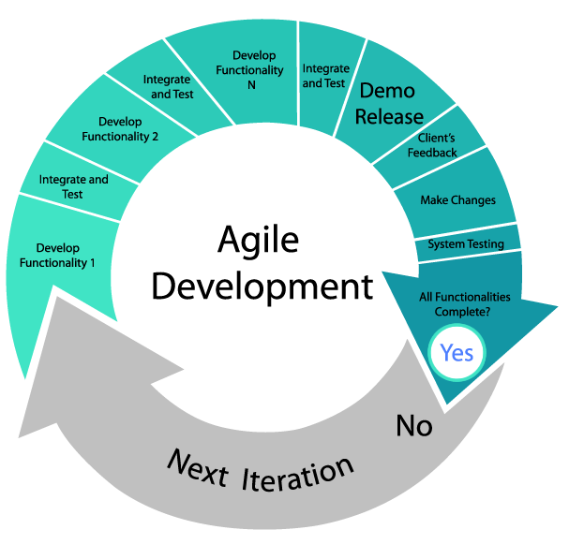

It is an approach to software development under which requirements and solutions evolve through the collaborative effort of self-organizing and cross-functional teams and their customers(s)/end user(s) It advocates adaptive planning, evolutionary development, early delivery, and continual improvement and it encourages rapid and flexible response to change.

The term *agile* (sometimes written *Agile*)[[3]](https://en.wikipedia.org/wiki/Agile_software_development" \l "cite_note-3) was popularized, in this context, by the *Manifesto for Agile Software Development.* The values and principles expoused in this manifesto were derived from and underpin a broad range of software development frameworks, including scrum and kanban.

There is significant anecdotal evidence that adopting agile practices and values improves the agility of software professionals, teams and organizations; however, some empirical studies have found no scientific evidence.

The Agile thought process had started early in the software development and started becoming popular with time due to its flexibility and adaptability.

The most popular Agile methods include Rational Unified Process (1994), Scrum (1995), Crystal Clear, Extreme Programming (1996), Adaptive Software Development, Feature Driven Development, and Dynamic Systems Development Method (DSDM) (1995). These are now collectively referred to as Agile Methodologies, after the Agile Manifesto was published in 2001.

Following are the Agile Manifesto principles −

* **Individuals and interactions** − In Agile development, self-organization and motivation are important, as are interactions like co-location and pair programming.
* **Working software** − Demo working software is considered the best means of communication with the customers to understand their requirements, instead of just depending on documentation.
* **Customer collaboration** − As the requirements cannot be gathered completely in the beginning of the project due to various factors, continuous customer interaction is very important to get proper product requirements.
* **Responding to change** − Agile Development is focused on quick responses to change and continuous development.

**3.4 Project Modules**

* **Home Page**

On Home page any user redirects firstly when he visits site. This page contains information about the website. If user has some queries regarding this website, he can send it’s query by filling the contact us form. To begin mock test of any particular subject. He needs to register (if he visits first time ) and then sign in to be eligible to give a mock test. After logging in, User can select the desired subject and begin the mock test.

* **Exam Panel**

When User selects the subject, He is redirected to the Exam Panel. Exam Panel has a timer. Each question has been allotted 2 Minutes. If user fails to answer the question in the given time, next question will be loaded. Each module have 3 difficulty level (Easy, Medium, Hard). After every 3 question, difficulty level will be checked. If 2 questions out of 3 are correct then difficulty level will increase.If 2 questions out of 3 are wrong then difficulty level will decrease. After completion of 15 questions. User will be redirected to Summary page.

* **Summary**

When User has completed the module then he is redirected to the summary page.

On summary page total no. of question attempted, no. of questions attempted at different difficulty level, total no. of correct answer, percentile of the current mock test and Subject accuracy is shown. However, Percentile and Subject Accuracy are calculated in different ways.

**Formula for percentile calculations:-**

**Percentile (%)** = Marks x 100

Total Marks

**Formula for Subject Accuracy Calculations:**

**Current Subject Accuracy (%)** = (Correct \_Easy \*1+Correct \_Medium \*2+Correct \_Hard \* 4)

Total Number of Marks

We have calculated Current Accuracy above, but it is not accurate. So, to calculate Subject Accuracy with precision, we take the Mean of the Old\_Accuracy (Fetched from database) and Current\_accuracy of the subject. So, we get the precise Subject Accuracy.

**Actual Subject Accuracy (%)** = (Accuracy \_Old ((Fetched from database)) + Accuracy

2

Actual Subject Accuracy is stored in the database for future purpose.

* **Admin Panel**

Admin Panel is the most vital part of any application. Whole control over application is through this page. To access the admin panel, authorised admin has to login. After login, Admin is redirected to the Admin Home page from where he manages everything. On Home page, Admin can view User Queries, list of all registered users. Admin can insert, update, and delete questions of various subjects and difficulty level.

**3.5 Diagrams**

**Data Flow Diagram**

**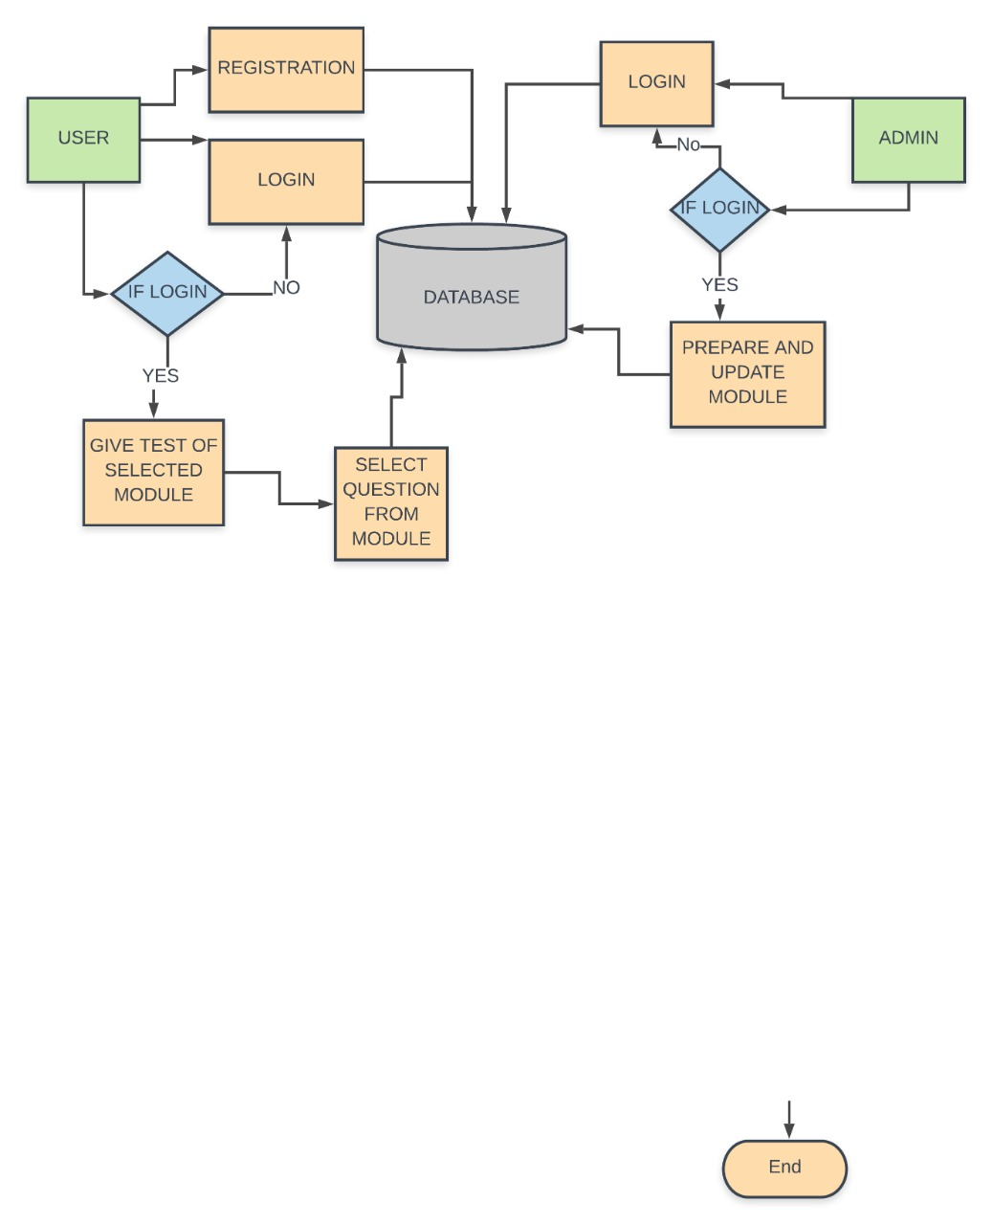**

Figure 1 : Data Flow Diagra`

**Use Case Diagram**

**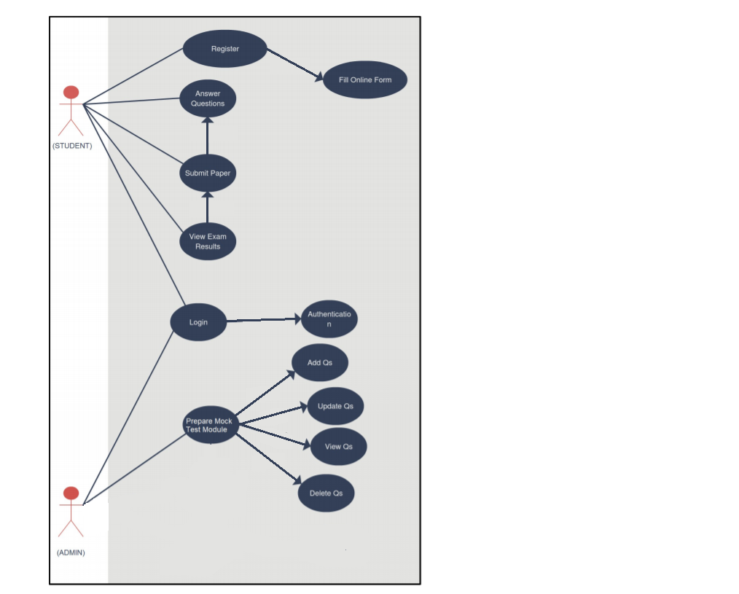**

Figure 2: Use Case Diagram

**ER Diagram**

**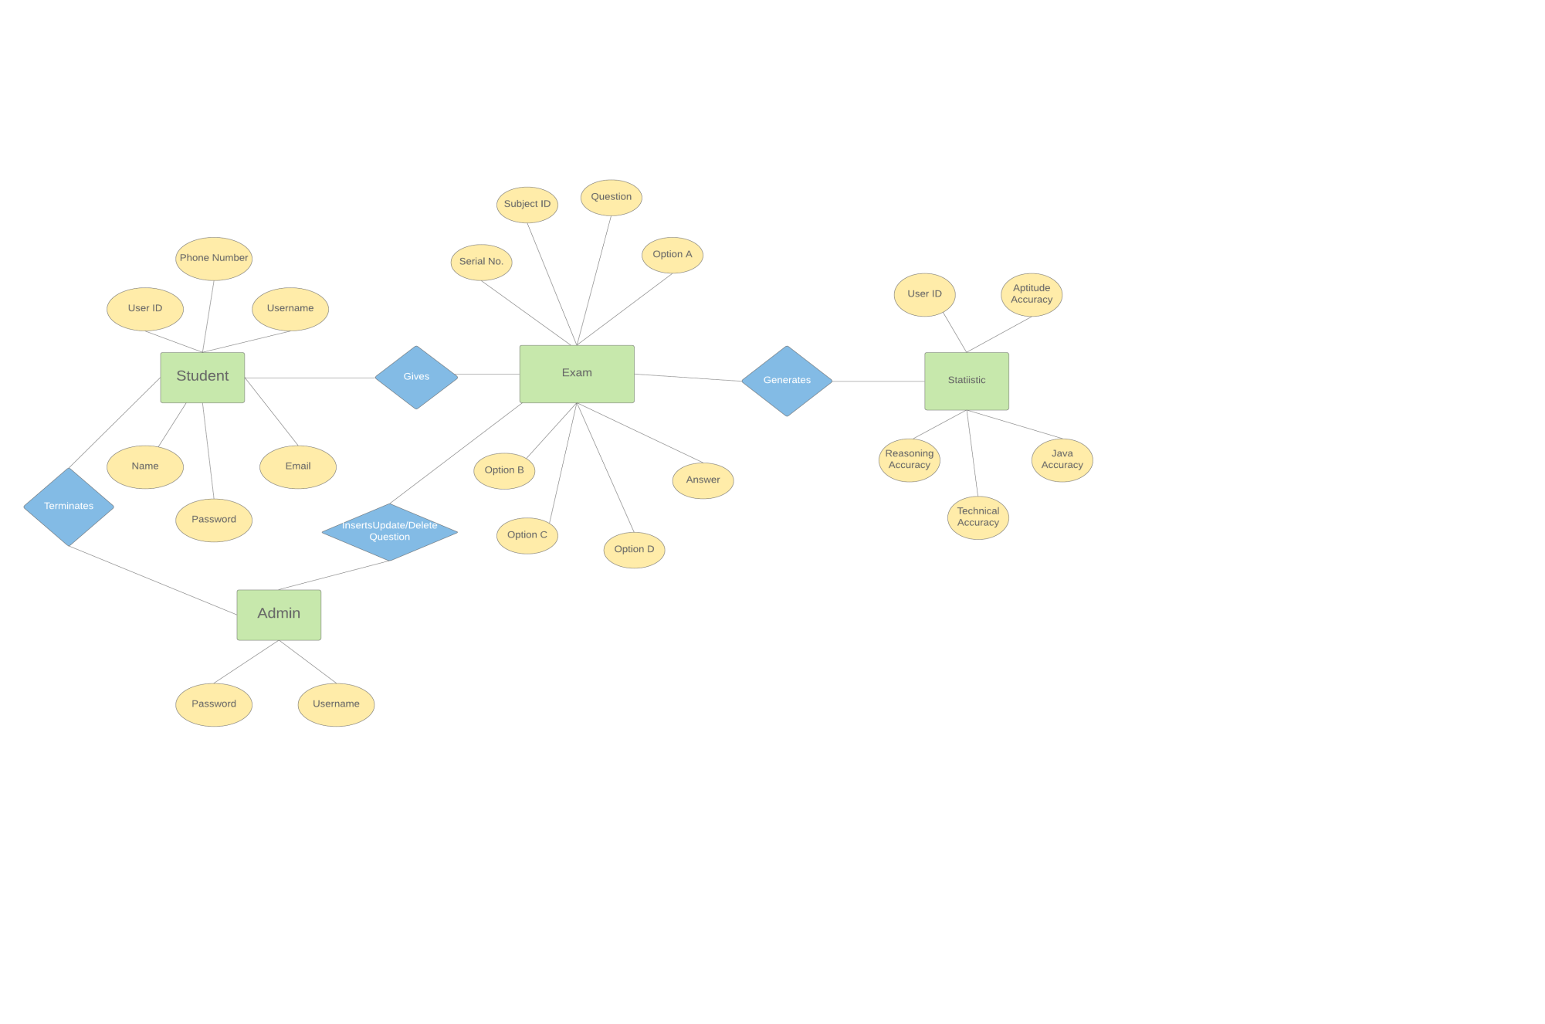**

Figure 3: ER Diagram

**Chapter 4**

**Implementations**

**4.1 Main Functions with explanation**

Main functions of student and admin are as follows

1. **Functions for Students**

* **Update Profile**

Student has a function to update his profile whenever needed.

* **Change Password**

If in case student forgets password, he can reset it.

* **Choose subject for mock test**

Student can select subject of its choice for mock test.

* **View Analysis Report**

Student can view Analysis Report.

1. **Functions for Admin**

* **Insert Question**

Admin can insert questions.

* **Update Question**

Admin can update questions.

* **Delete Question**

Admin can delete questions.

* **Reply to User Queries**

Admin can reply to user queries

* **View/Delete Students**

Admin can view/delete students

**4.2 Coding with explanation**

**Welcome-File lists in web.xml**

The welcome-file-list element of web-app, is used to define a list of welcome files. Its sub element is welcome

file that is used to define the welcome file. A welcome file is the file that is invoked automatically by the server

if you don't specify any file name. If welcome-file-list entry doesn't exist in web.xml file, priority goes

to index.html file then index.htm and at last index.jsp file. In our case we have used Home.jsp as the welcome

file.

<welcome-file-list>

<welcome-file>Home.jsp</welcome-file>

</welcome-file-list>

If you have the welcome file, you can directory invoke the project as given below:

http://localhost:8091/oaap1

As you can see, we have not specified any file name after the project.

We will be redirectect to Home.jsp

**Home Page**

When a user visits website ‘Online Adaptive Assessment Platform’. He firstly needs to visit Home Page. This is the main page through which every page can be accessed in the web-application.

* **Meta Tags**

The <**meta**> **tag** provides **metadata** about the **HTML** document.**Metadata** will not be displayed on the page, but will be machine parsable. **Meta** elements are typically used to specify page description, keywords, author of the document, last modified, and other **metadata**.

<meta charset="utf-8">

<meta name="viewport" content="width=device-width, initial-scale=1.0, shrink-to fit=no, maximum- scale=1, user-scalable=0">

* **Bootstrap CDN(Content Delivery Network) links**

**BootstrapCDN** is a public [content delivery network](https://en.wikipedia.org/wiki/Content_delivery_network). Users of Bootstrap CDN can load [CSS](https://en.wikipedia.org/wiki/CSS), [JavaScript](https://en.wikipedia.org/wiki/JavaScript) and images remotely, from its servers. Bootstrap uses [StackPath](https://en.wikipedia.org/wiki/StackPath" \o "StackPath)'s global content delivery network, which makes websites using its service resilient to unexpected surges in [web traffic](https://en.wikipedia.org/wiki/Web_traffic).

<script src="https://code.jquery.com/jquery-3.3.1.slim.min.js" ></script>

<link rel="stylesheet" href="https://stackpath.bootstrapcdn.com/bootstrap/4.2.1/css/bootstrap.min.css" >

<script src="https://stackpath.bootstrapcdn.com/bootstrap/4.2.1/js/bootstrap.min.js" ></script>

<link rel="stylesheet" href="https://use.fontawesome.com/releases/v5.7.0/css/all.css">

* **External CSS And JavaScript Files Links**

CSS3 supports external style sheets*.* This technique allows you to define a style sheet as a separate document and import it into your web pages.

<link rel="stylesheet" type="text/css" href="Home.css"/>

<script src="Home.js"></script>

* **Navigation Bar**

The **HTML** <nav> element represents a section of a page whose purpose is to provide **navigation** links, either within the current document or to other documents.

<nav class="navbar navbar-expand-md navbar-dark fixed-top">

<ul><li class="nav-item">

<a class="nav-link" href="#"> Link Name</a></li></ul>

</nav>

* **Sign up Page**

**Sign up** essentially means to join the ranks of a group of users, or somehow affiliate oneself with an organization or enterprise of sorts. So firstly every student needs to register themselves and thereafter they can continue.

* **Form**

A webform, web form or HTML form on a web page allows a user to enter data that is sent to a server for processing. Forms can resemble paper or database forms because web users fill out the forms using checkboxes, radio buttons, or text fields.

* **Method**

The method attribute specifies how to send form-data (the form-data is sent to the page specified in the action attribute). There are 2 types of methods; GET & POST. The form-data can be sent as URL variables (with method="get") or as HTTP post transaction (with method="post").

GET method is Useful for form submissions where a user want to bookmark the result. It is better for non-secure data, like query strings in Google.

POST method Appends form-data inside the body of the HTTP request (data is not shown is in URL).Form submissions with POST cannot be bookmarked.

* **Action**

A **form** is useless unless some kind of processing takes place after the **form** is submitted. The **action** attribute is **used** to inform the browser what page (or script) to call once the "submit" button is pressed.

* **Label**

The <**label**> tag is used to create **labels** for items in a user interface. Typically used within <input> tags on a form, the <**label**> tag is additionally useful because it extends the clickable area of control elements, like buttons.

* **Input**

The <**input**> tag specifies an **input** field where the user can enter data. <**input**> elements are used within a <form> element to declare **input** controls that allow users to **input** data. An **input** field can vary in many ways, depending on the type attribute.

* **Name Attribute**

The **name** attribute is used to reference form-data after the form has been submitted

* **Placeholder**

The short hint is displayed in the input field before the user enters a value.

* **Button**

The <**button**> tag defines a clickable **button**. Inside a <**button**> element you can put content, like text or images.

* Below given form can contain input fields such as Name, Email, Mobile number, Username , Password etc.
* After clicking on **Sign Up** button, **register\_user.jsp** page is called and whole information contained in the form(enter by user ) will be forwarded so that it can be accessed from the specified page.

<form action="register\_user.jsp" method="post”>

<label> Name/ Email/ Mobile no/ Username/ Password </label>

<input type="text" name="register\_name" placeholder="Enter Name">

<button type="submit">Sign Up</button>

</form>

* **Store User Information**

When user clicks on **Sign Up** button, **register\_user.jsp** page is called and information is stored in the database.

Firstly we fetch information which was submitted by user. We access it by using the name we have provided in the input tag.

String name= request.getParameter("register\_name");

We create the object of the class that is needed to access the function inside it.

oaapUserDao oud=new oaapUserDao();

Now we call the function **oaapUserInfo** which is inside **oaapUserDao** class.In that function we pass values entered by the user.

int status=oud.oaapUserInfo(name,username,password,email,phone);

**oaapUserDao class**

To store information in the database, firstly we need to establish a connection and then we need to execute query.

Class.forName("oracle.jdbc.driver.OracleDriver");

con=DriverManager.getConnection("jdbc:oracle:thin:@localhost:1521:xe","system","nilay");

Connection con=oaapUserDao.getConnection();

After establishing a connection with database we write a query to execute:

PreparedStatement ps=con.prepareStatement("insert into ooa\_userinfo values (user\_id\_seq.nextval,?,?,?,?,?)");

Now we input values and calls a **execute update** method over a prepared statement object.

status=ps.executeUpdate();

Now if status is equal to zero it means data have been successfully inserted into the database.

if(status==1){

Now we call send Redirect method over response object to redirect to the **Home.jsp** page.

}

* **Login Page**

**login**, logging in or logging on is the entering of identifier information into a system by a user in order to access that system. A **login** generally requires the user to enter two pieces of information, first a user name and then a password.

* **Form**

A webform, web form or HTML form on a web page allows a user to enter data that is sent to a server for processing. Forms can resemble paper or database forms because web users fill out the forms using checkboxes, radio buttons, or text fields.

* **Method**.

In this form we use **POST** method

POST method Appends form-data inside the body of the HTTP request (data is not shown is in URL).Form submissions with POST cannot be bookmarked.

* **Action**

A **form** is useless unless some kind of processing takes place after the **form** is submitted. The **action** attribute is **used** to inform the browser what page (or script) to call once the "submit" button is pressed.

<form action="login.jsp" method="post" name="signin">

<label id="username\_label">Username</label>

<input type="text" name="username" id="username" placeholder="Enter Username" style="">

<label id="password\_label">Password</label><!--password-->

<input type="password" name="password" id="password" placeholder="Enter password">

<button type= “submit”>Login</button>

</form>

After clicking on **Sign Up** button, **login.jsp** page is called and whole information contained in the form (enter by user) will be forwarded so that it can be used to validate from the specified page.

* **Validate User Information**

When user clicks on **Login** button, **login.jsp** page is called and information is validated by fetching the user information and matching it with the value entered by the user.

Firstly we fetch information which was submitted by user. We access it by using the name attribute we is inside the input tag.

String username=request.getParameter("username");

We create the object of the class that is needed to access the function inside it.

oaapUserDao oud=new oaapUserDao();

Now we call the function **oaapUserValidate** which is inside **oaapUserDao** class.In that function we pass values entered by the user.

Status=oud.oaapUserValidate(username,password);

* **oaapUserDao class**

To fetch information from the database, firstly we need to establish a connection and then we need to execute a query.

Class.forName("oracle.jdbc.driver.OracleDriver");

con=DriverManager.getConnection("jdbc:oracle:thin:@localhost:1521:xe","system","nilay"); Connection con=oaapUserDao.getConnection();

After establishing a connection with database we write a query to execute:

PreparedStatement preparedstatement=con.prepareStatement("select \* from ooa\_userinfo where username=? and password=?");

Now we input values and calls a **execute query** method over a prepared statement object.

ResultSet rs=ps.executeQuery();

If we get something in resultset object that means user has entered correct information. And this block will run and we will get the status. So that we can return its value to tell user **is valid.**

{

Set status equal to one

}

If status is equal to one we set attribute over a session object.

{

We have given unique name to the attribute and correspondingly we have attached a value with it.

session.setAttribute("question\_counter","1");

And also we call send Redirect method over response object to redirect to the **Home.jsp** page.

}

* **Session**

**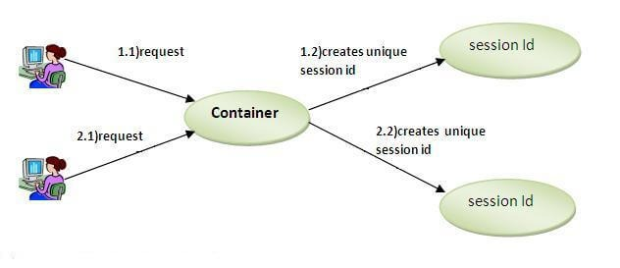**

Session simply means a particular interval of time. Session Tracking is a way to maintain state (data) of an user. It is also known as session management.

Http protocol is a stateless so we need to maintain state using session tracking techniques. Each time user requests to the server, server treats the request as the new request. So we need to maintain the state of an user to recognize to particular user.

HTTP is stateless that means each request is considered as the new request.

In such case, container creates a session id for each user.The container uses this id to identify the particular user.An object of HttpSession can be used to perform two tasks:

1.) bind objects

2.) view and manipulate information about a session, such as the session identifier, creation time, and last accessed time.

In JSP, session is an implicit object of type HttpSession.The Java developer can use this object to set,get or remove attribute or to get session information.

To set the attribute in the session scope, we have used the setAttribute() method of HttpSession interface and to get the attribute, we have used the getAttribute() method.

session.setAttribute("name","value");

session.getAttribute("name");

getAttribute() method return an object of session class so we have to typecast it to string.

* **Exam Panel Page**

Answer check is a function by which we find that weather the submitted option by user is correct or not. In this we also calculate the total number of correct answer given by user, number of correct answer given by user at different difficulty.

answercheck(option,difficulty,answer,marks,correct\_answer)

{

if(option==answer)

{

correct\_answer=correct\_answer+1;

marks=marks+1;

if(difficulty==1)

{

increment correct easy count

}

if(difficulty==2)

{

increment correct medium count

}

if(difficulty==3)

{

increment correct medium count

}

}

else

do nothing;

}

* Increment function is used to increment the value of any given variable

increment(value)

{

return value+1;}

* Check Difficulty

Class Check Difficulty is for checking the difficulty level of the module. It has a function difCheck in it, which need 3 parameter question count, correct count and current difficulty level.

Check Difficulty (question count, correct count , current difficulty level)

This function works as follows:

It checks the question count.

If question count is equal to 3:

{

Then it checks the correct count.

If correct count is less than 2:

{

Then it checks the current difficulty level.

if difficulty level is equal to 1 then it return the same.

Else it decrements the current difficulty level by 1 and returns the value.

}

else if correct count is not less then 2:

{

it again checks the current difficulty level.

If difficulty level is equal to 3 then it returns the same.

Else it increments the current difficulty level by 1 and returns the value.

}

}

Else if question count is not equal to 3:

{

It returns the current difficulty.

}

* **Admin Panel**

Admin Panel is the most vital part of any application. Whole control over application is through this page. To access the admin panel, authorised admin has to login. After login, Admin is redirected to the Admin Home page from where he manages everything. On Home page, Admin can view User Queries, list of all registered users. Admin can insert, update, and delete questions of various subjects and difficulty level.

**Main operations done by admin**

* **Admin can insert question**

On **Admin Insert** UIpage, Admin enters Question Number, Question, Answer, Option A, Option B, Option C and Option D. After clicking on insert button, page is redirected to **admin\_insert.jsp,** on which **oaapQuestionInsert** function is called to insert values in the database.

int status=oad.oaapQuestionInsert(subject,difficulty,sno,question,answer,a,b,c,d);

if status equal to 1 that means values has been successfully inserted

{

Page is redirected to **Admin Insert** UI.

}

else{

Page is redirected to **Admin Insert** UI.

}

* **Admin can update question**

On **Admin Update** UIpage, Admin can update Question Number, Question, Answer, Option A, Option B, Option C and Option D. After clicking on update button, page is redirected to **admin\_update.jsp,** on which **oaapQuestionUpdate** function is called to update values in the database.

int status=oad.oaapQuestionUpdate(subject,difficulty,sno,question,answer,a,b,c,d);

if status is greater than zero that means values has been successfully updated.

{

Page is redirected to **Admin Update** UI.

}

else{

Page is redirected to **Admin Update** UI.

}

* **Admin can delete question**

On **Admin Delete** UIpage, Admin can delete any Question using Question Number. After clicking on delete button, page is redirected to **admin\_delete.jsp,** on which **oaapQuestionDelete** function is called to delete values from the database.

int status=oad.oaapQuestionDelete(question\_no);

if status is greater than zero that means row has been successfully deleted.

{

Page is redirected to **Admin Delete** UI.

}

else{

Page is redirected to **Admin Delete** UI.

}

**Chapter 5:**

**Results**

* **HOME PAGE**

**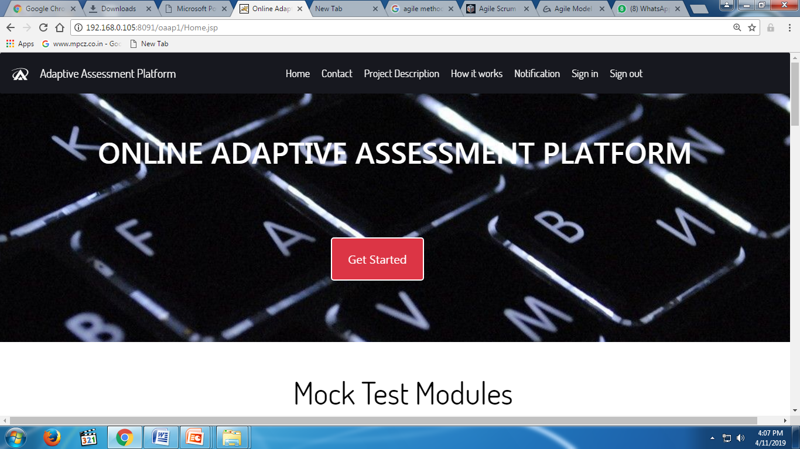**

Figure 1: Home Page

* **LOGIN FORM**

**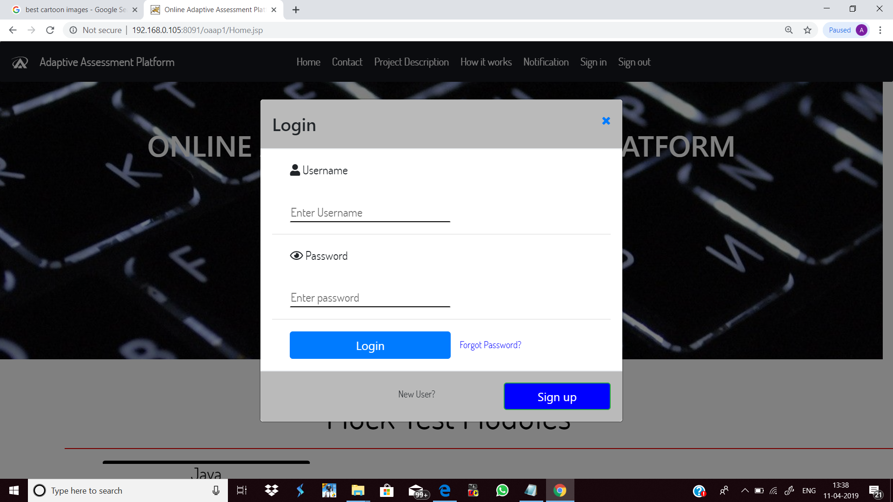**

Figure 2: Login Form

* **SIGN UP FORM**

**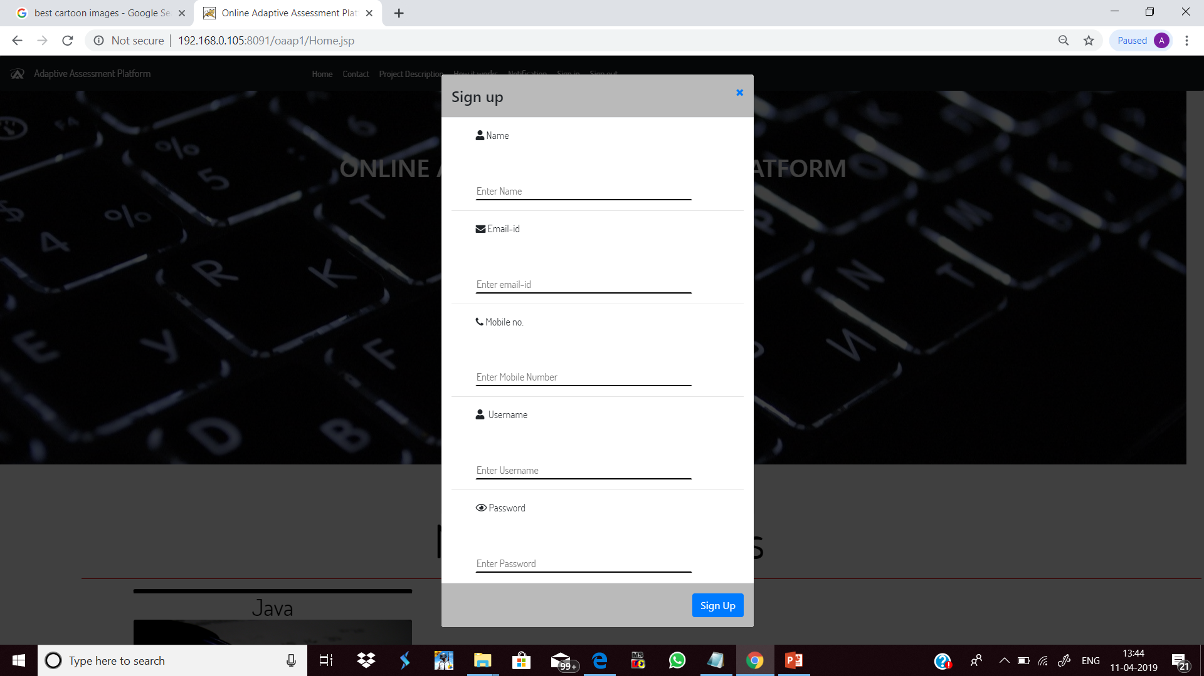**

Figure 3: Sign Up Form

* **MOCK TEST MODULES**

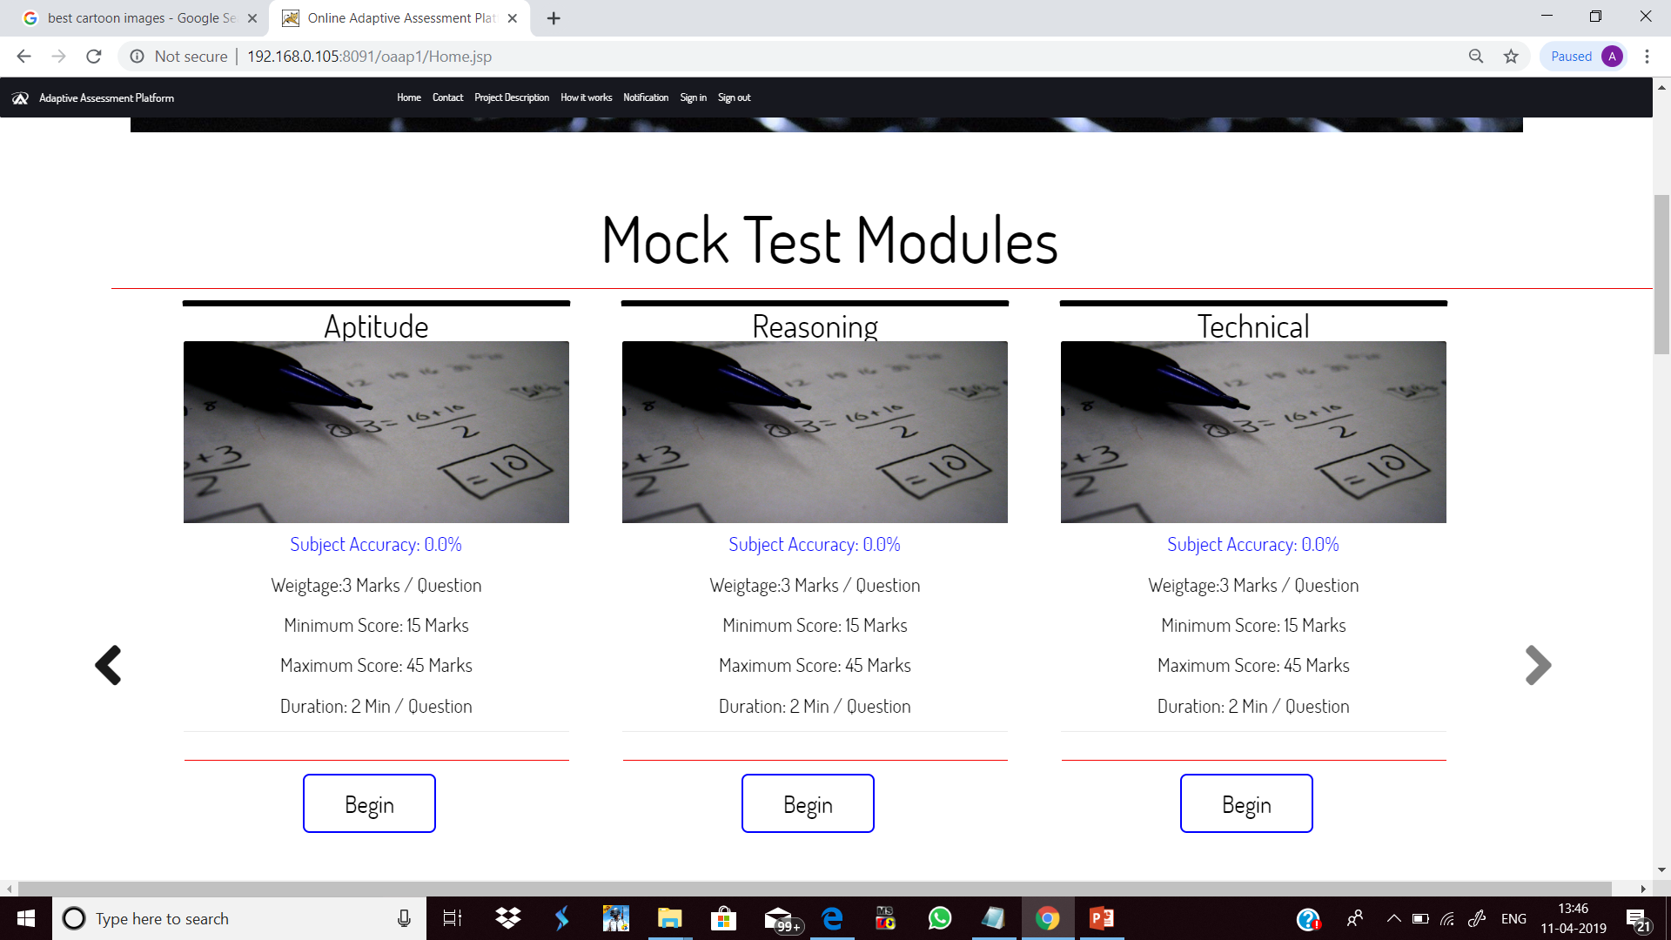

Figure 4: Mock Test Modules

* **CONTACT US FORM**

**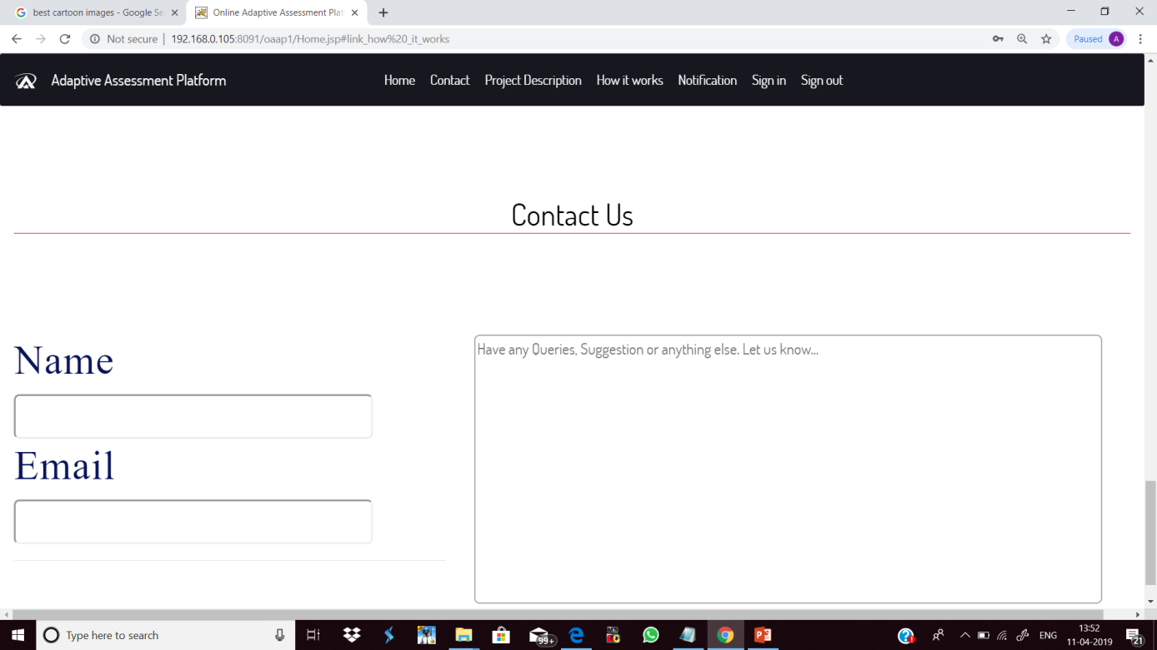**

Figure 5: Contact Us Form

**EXAM PANEL PAGE** 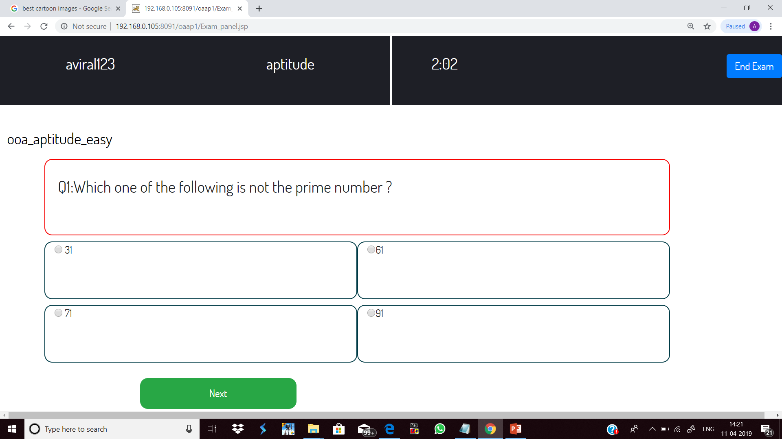

Figure 6: Exam Panel Page

* **SUMMARY PAGE**

**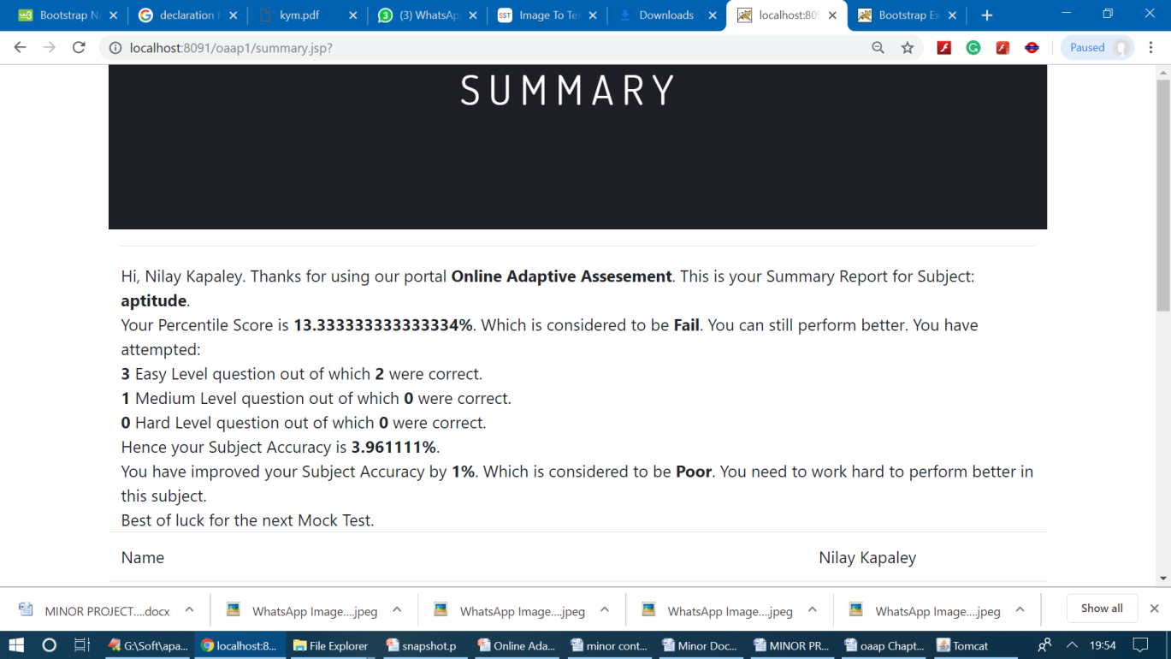 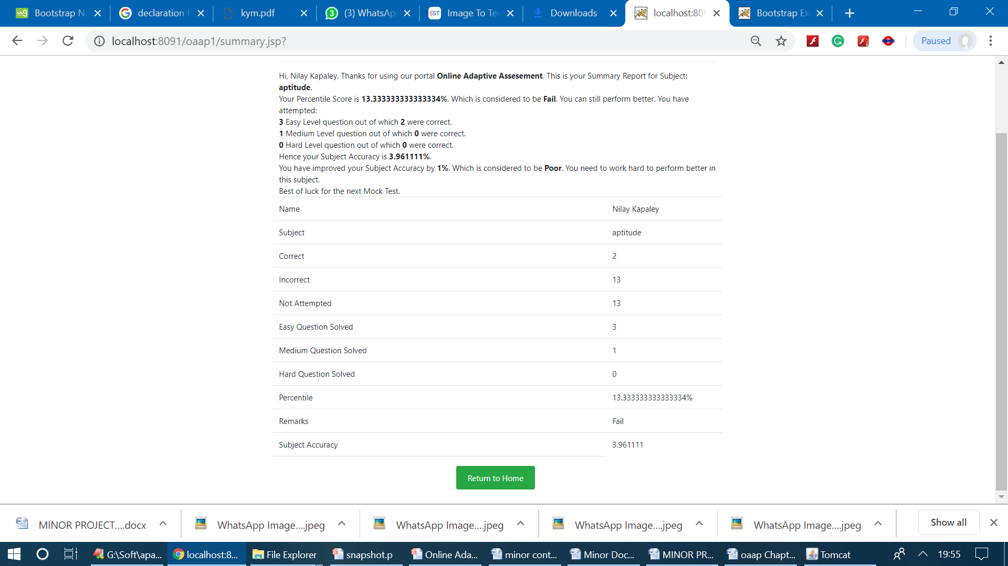**

Figure 7: Summary Page

**ADMIN PAGE**

* **LOGIN PAGE**

**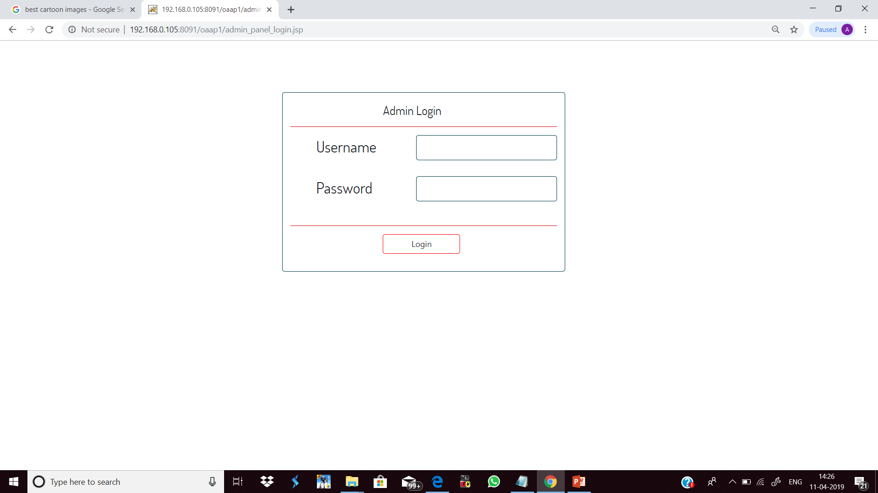**

Figure 8: Admin Login Page

* **ADMIN HOME**

**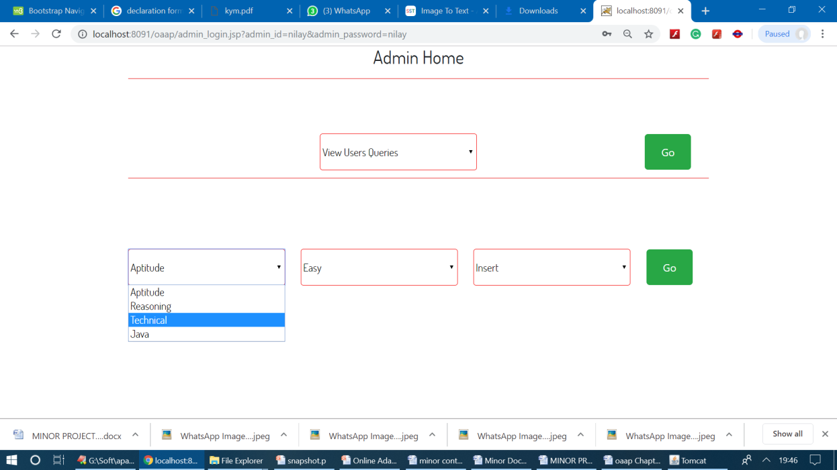**

Figure 9: Admin Home Page

* **QUESTION INSERT PAGE**

**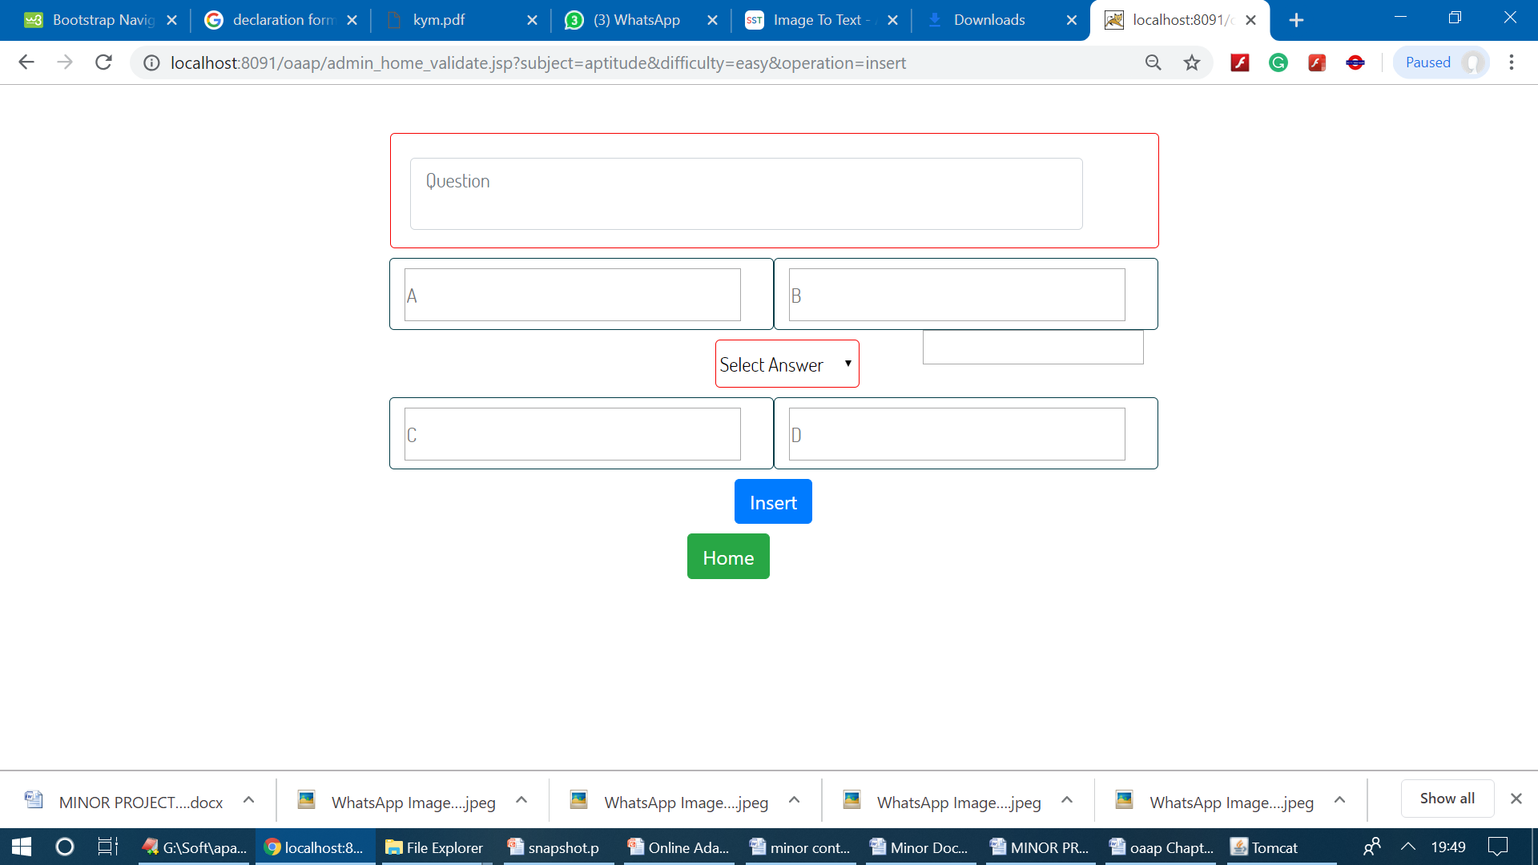**

Figure 10: Question Insert Page

* **QUESTION UPDATE PAGE**

**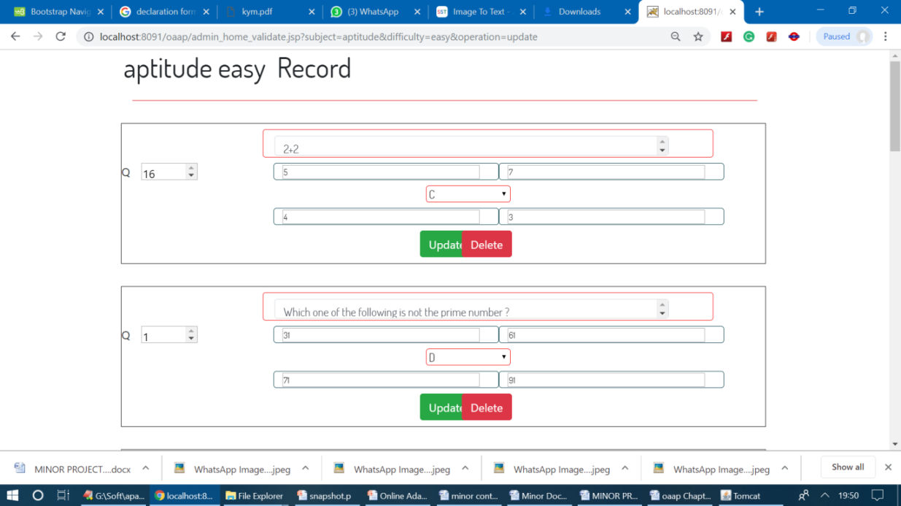**

Figure 11: Question Update/Delete

* **VIEW USER QUERIES**

**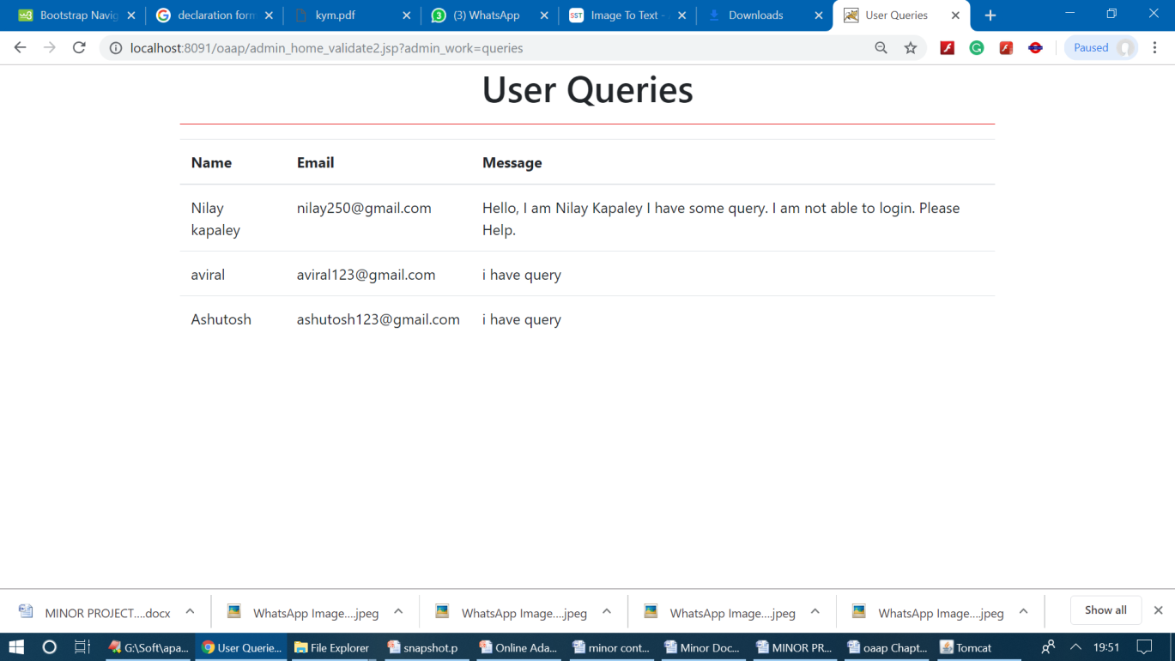**

Figure 12: View User Queries

* **VIEW REGISTERED USERS**

**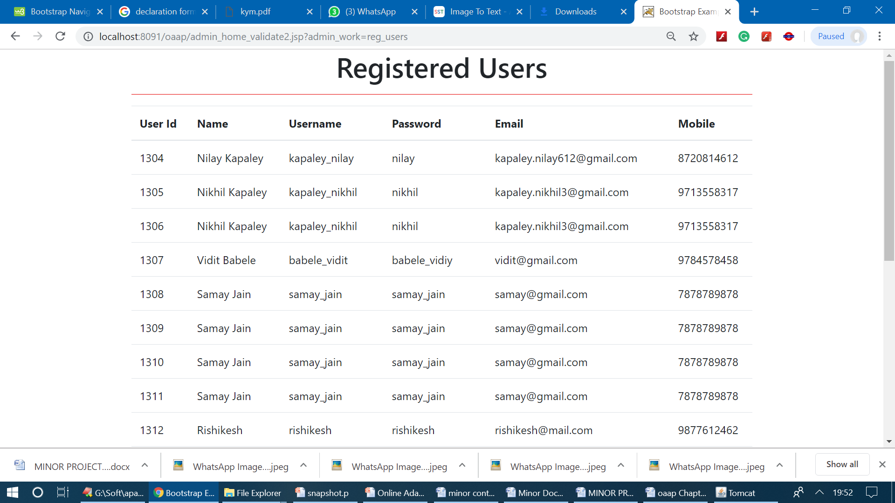**

Figure 13: View Registered Users

**TABLES**

**Table 1: Userinfo**

|  |  |  |
| --- | --- | --- |
| **FIELD NAME** | **DATA TYPE** | **NULL** |
| USERID | INT(3) | NOT NULL |
| NAME | VARCHAR2(30) | NOT NULL |
| USERNAME | VARCHAR2(30) | NOT NULL |
| PASSWORD | VARCHAR2(30) | NOT NULL |
| EMAIL | VARCHAR2(30) | NOT NULL |
| PHONE | INT(10) | NOT NULL |

**Table 2: Aptitude Easy/Medium/Hard**

|  |  |  |
| --- | --- | --- |
| **FIELD NAME** | **DATA TYPE** | **NULL** |
| SNO | INT(3) | NOT NULL |
| SID | INT(3) | NOT NULL |
| QUESTION | VARCHAR2(250) | NOT NULL |
| A | VARCHAR2(100) | NOT NULL |
| B | VARCHAR2(100) | NOT NULL |
| C | VARCHAR2(100) | NOT NULL |
| D | VARCHAR2(100) | NOT NULL |
| ANSWER | VARCHAR2(100) | NOT NULL |

**TABLE 3: Contact Us**

|  |  |  |
| --- | --- | --- |
| **FIELD NAME** | **DATA TYPE** | **NULL** |
| NAME | VARCHAR2(30) | NOT NULL |
| EMAIL | VARCHAR2(30) | NOT NULL |
| MESSAGE | VARCHAR2(30) | NOT NULL |

**TABLE 4: Reasoning Easy/Medium/Hard**

|  |  |  |
| --- | --- | --- |
| **FIELD NAME** | **DATA TYPE** | **NULL** |
| SNO | INT(3) | NOT NULL |
| SID | INT(3) | NOT NULL |
| QUESTION | VARCHAR2(250) | NOT NULL |
| A | VARCHAR2(100) | NOT NULL |
| B | VARCHAR2(100) | NOT NULL |
| C | VARCHAR2(100) | NOT NULL |
| D | VARCHAR2(100) | NOT NULL |
| ANSWER | VARCHAR2(100) | NOT NULL |

**TABLE 5: Technical Easy/Medium/Hard**

|  |  |  |
| --- | --- | --- |
| **FIELD NAME** | **DATA TYPE** | **NULL** |
| SNO | INT(3) | NOT NULL |
| SID | INT(3) | NOT NULL |
| QUESTION | VARCHAR2(250) | NOT NULL |
| A | VARCHAR2(100) | NOT NULL |
| B | VARCHAR2(100) | NOT NULL |
| C | VARCHAR2(100) | NOT NULL |
| D | VARCHAR2(100) | NOT NULL |
| ANSWER | VARCHAR2(100) | NOT NULL |

**TABLE6: Java Easy/ Medium / Hard**

|  |  |  |
| --- | --- | --- |
| **FIELD NAME** | **DATA TYPE** | **NULL** |
| SNO | INT(3) | NOT NULL |
| SID | INT(3) | NOT NULL |
| QUESTION | VARCHAR2(250) | NOT NULL |
| A | VARCHAR2(100) | NOT NULL |
| B | VARCHAR2(100) | NOT NULL |
| C | VARCHAR2(100) | NOT NULL |
| D | VARCHAR2(100) | NOT NULL |
| ANSWER | VARCHAR2(100) | NOT NULL |

**TABLE 7: User Statistic**

|  |  |  |
| --- | --- | --- |
| **FIELD NAME** | **DATA TYPE** | **NULL** |
| USER ID | INT(3) | NOT NULL |
| APTITUDE | VARCHAR2(30) | NOT NULL |
| REASONING | VARCHAR2(30) | NOT NULL |
| TECHNICAL | VARCHAR2(30) | NOT NULL |
| JAVA | VARCHAR2(30) | NOT NULL |

**TABLE 8: ADMIN INFO**

|  |  |  |
| --- | --- | --- |
| **FIELD NAME** | **DATA TYPE** | **NULL** |
| USERID | INT(3) | NOT NULL |
| NAME | VARCHAR2(30) | NOT NULL |
| USERNAME | VARCHAR2(30) | NOT NULL |
| PASSWORD | VARCHAR2(30) | NOT NULL |
| EMAIL | VARCHAR2(30) | NOT NULL |
| PHONE | INT(10) | NOT NULL |

**Chapter VI**

**USER MANUAL**

* 1. **SOFTWARE REQUIREMENT**

The Software requirement in this project includes:

* Apache Tomcat: Apache Tomcat is used to deploy  **Java** Servlets and JSPs. So basically Apache is an HTTP Server, serving HTTP. Tomcat is a Servlet and JSP Server serving **Java** technologies.
* Web Browser: Internet Explorer, Mozilla Firefox, Google Chrome, etc.

**6.2 HARDWARE REQUIREMENT**

Hardware requirements for deployment are:

* Processor: Intel Pentium Family and above.
* RAM: 1GB and above.
* Hard Disk: 80GB.

**6.3 STEPS TO RUN PROJECT**

* Start Apache Tomcat server
* Open a browser like Google Chrome and enter the path of the file, or index page Eg.

<http://localhost:8091/oaap1/Home.jsp>.

* Writing path will lead you to the Home page of the project.
* From Here, any User can assess the web application entitled ‘Online Adaptive Assessment Plaform’

**Chapter 7:**

**Conclusion and Future Scope**

**7.1 Conclusion**

Online assessment is an important step inside the e-learning process because gives convenient feedback to all participants in the process, helping to improve the learning and teaching experience. In this paper we wanted to emphasize the role of the assessment by putting it at the centre‟ of the e-learning process and defining the importance factors to the main elements that participate in this process: the educative content and adaptation process, the users or students and the teachers and assessors. Definably the assessment activity takes place in a specific point of the process as we show it in the figure 1, and we conceptualized the activity as the link that closes the chain of the e-learning process. According to the new developments in the area of e-learning we can see that most of them look to be compliant with accepted standards like the LTS. This gives the convenience to those developments to be interoperable and adaptable to different platforms. In concordance, referring to the assessment activity we can think that it must be interoperable as well, because it is one element of the e-learning process and plays an important role inside this experience. When we talk about assessment we could define some components of quality, especially for the users; some of those are: validity, reliability, flexibility and Fairness. Adaptability is another key factor in assessment. Given the fact that assessment is an important element of the e-learning process and that this process looks to be interoperable, then we can think that the assessment tool could be used with different educative content administrators with different conceptualizations and ways to design and apply a test for their students. To face this situation it is necessary to develop an assessment tool that give several ways to design an test with different types of resources, different kind of assessments, group of students, kind of questions, managing schedules, etc. The results obtaining from the application of this tool to a group of students reported better scores when the test were adapted to the preferences of presentation. We are working now in the description of the final conclusions of this work.

**7.2 Future Work**

In this application, firstly some runtime bugs can be removed which would enhance the user experience. There are few more modules we can add. Below are the lists of modules we can integrate in our application:-

* We can integrate SMS API, Mail API.
* We can add Automata for programmers.
* After completion of mock test, a PDF file can be generated composed of solutions of the problem.

**Chapter 8:**

**References**

1. [**www.w3schools.com**](http://www.w3schools.com)
2. [**www.javatpoint.com**](http://www.javatpoint.com)
3. [**www.techopedia.com**](http://www.techopedia.com)
4. [**www.wikipedia.com**](http://www.wikipedia.com)
5. [**www.geeksforgeeks.com**](http://www.geeksforgeeks.com)
6. [**www.indizbiz.com**](http://www.indizbiz.com)
7. [**www.tutorialspoint.com**](http://www.tutorialspoint.com)
8. [**www.prepinsta.com**](http://www.prepinsta.com)
9. [**www.smallseotools.com**](http://www.smallseotools.com)
10. [**www.java2s.com**](http://www.java2s.com)